A

Project Report on

EasyWatch

(Movie Streaming Platform)

Developed at

## RapidOps INC., Ahmedabad, Gujarat 380060, India

Developed by

## Preeti. **Chauhan - IT014** – Department of IT, DDU

**Vivek H. Rajpara - IT127 – Department of IT, DDU**

|  | **Guided By** |  |
| --- | --- | --- |
| **Internal Guide :** |  | **External Guide :** |
| Prof. N.P.Desai |  | Ravindra Singh |
| Faculty of Department of IT |  | Training Specialist |
| Faculty of Technology DDU |  | RapidOps Inc.,Ahmedabad |



## Department of Information Technology,

## Dharmsinh Desai University

## **College Road, Nadiad-387001**

## **April – 2023**

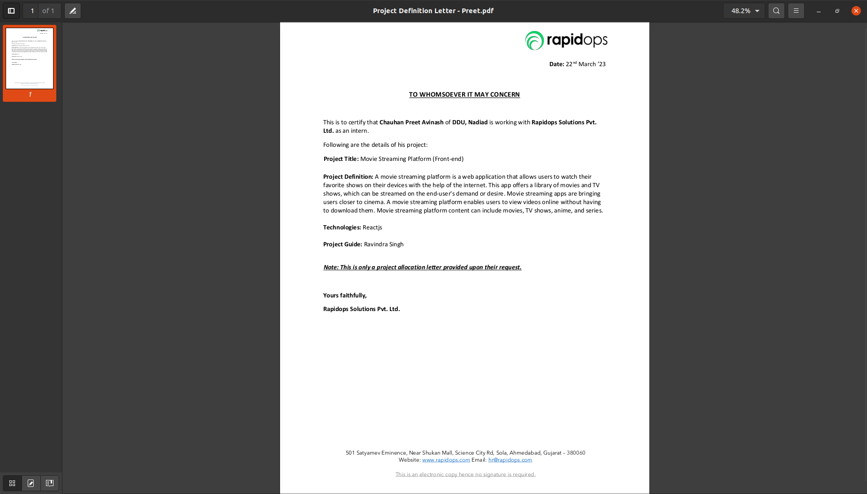

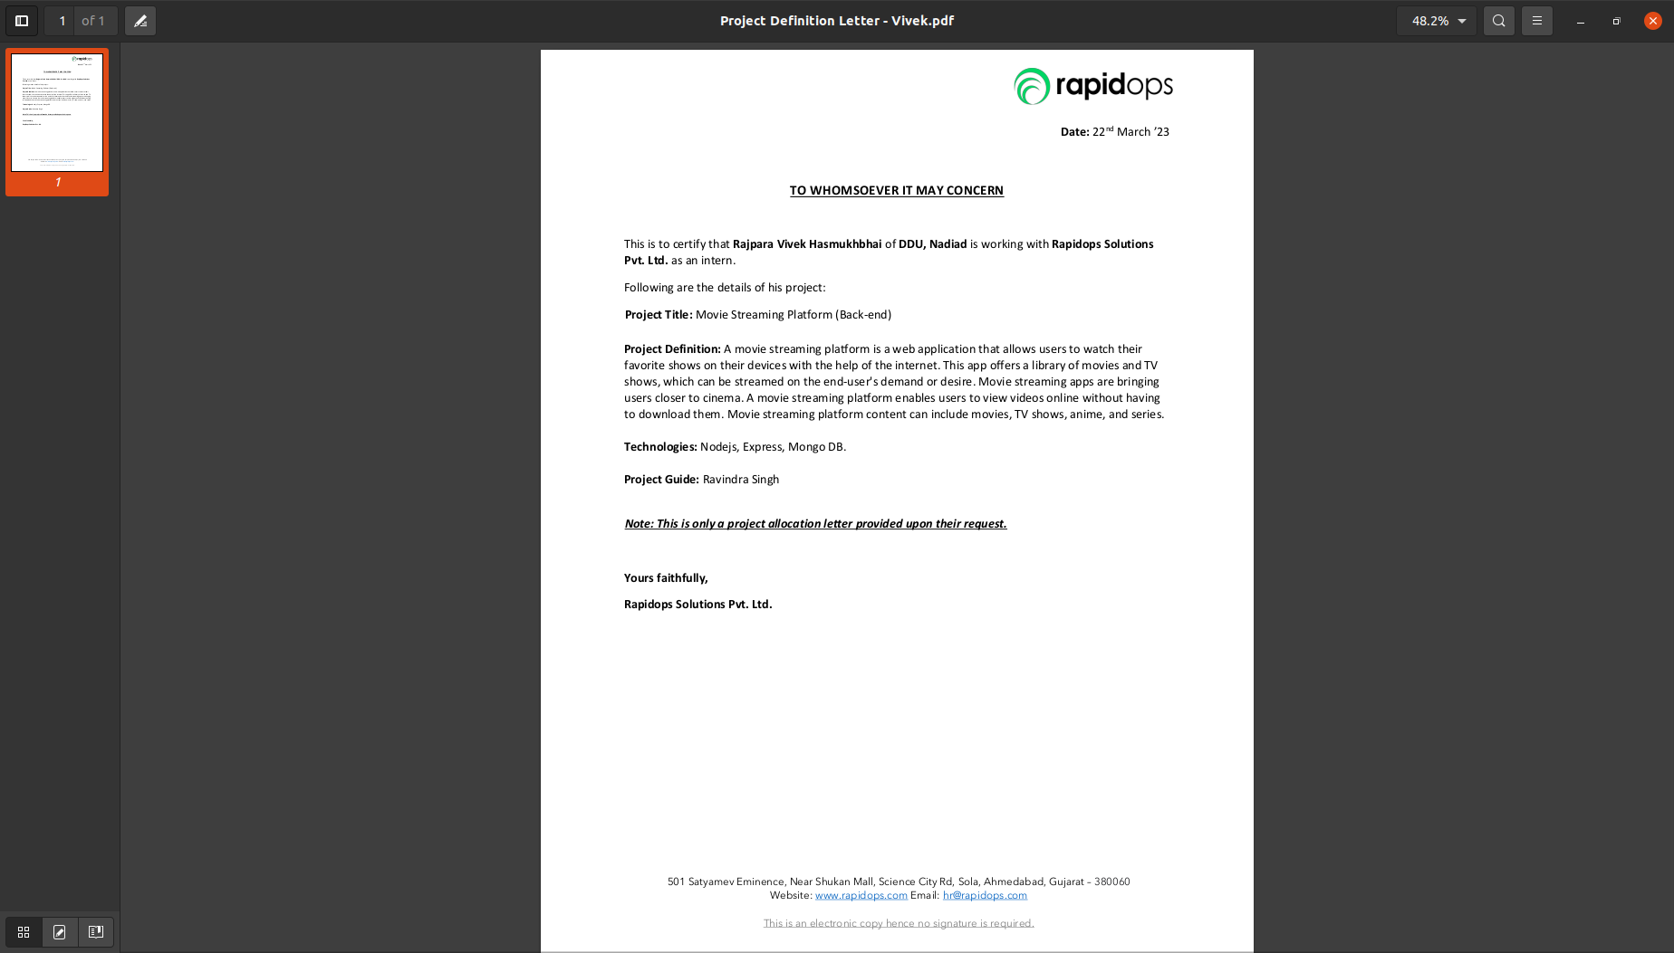

I declare that the final semester report entitled “**EasyWatch(Movie Streaming Platform)**” is my own work conducted under the supervision of the external guide  **Ravindra Singh** from **RapidOps INC.**

I further declare that to the best of my knowledge the report for B.Tech. final semester does not contain part of the work which has been submitted for the award of B.Tech. Degree either in this or any other university without proper citation.

Also I declare that following students also worked in this project:

**Vivek Rajpara** – Department of IT, DD University

Candidate’s Signature

Candidate’s Name: **Preet Chauhan**

Branch: Information Technology Student ID: 19ITUBS145

I declare that the final semester report entitled “**EasyWatch(Movie Streaming Platform)**” is my own work conducted under the supervision of the external guide  **Ravindra Singh** from **RapidOps INC.**

I further declare that to the best of my knowledge the report for B.Tech. final semester does not contain part of the work which has been submitted for the award of B.Tech. Degree either in this or any other university without proper citation.

Also I declare that following students also worked in this project:

**Preet Chauhan** – Department of IT, DD University

Candidate’s Signature

Candidate’s Name: **Vivek Rajpara**

Branch: Information Technology

Student ID: 19ITUNES049

# DHARMSINH DESAI UNIVERSITY

**NADIAD-387001, GUJARAT**



# CERTIFICATE

This is to certify that the project entitled “**EasyWatch(Movie Streaming Platform)**” is a bonafide report of the work carried out by

#### Mr Preet Chauhan, Student ID No: 19ITUBS145

1. **Mr Vivek Rajpara, Student ID No: 19ITUES049**

of Department of Information Technology, semester VIII, under the guidance and supervision for the award of the degree of Bachelor of Technology at Dharmsinh Desai University, Nadiad (Gujarat). They were involved in Project training during the academic year 2021-2022.

#### Prof. N.P. Desai

(Project Guide)

Department of Information Technology, Faculty of Technology,

Dharmsinh Desai University, Nadiad Date:

#### Prof. (Dr.)V K Dabhi,

Head of Department of Information Technology,

Faculty of Technology,

Dharmsinh Desai University, Nadiad Date:

**ACKNOWLEDGMENT**

It is truly a pleasure to express our thanks and gratitude to everyone who has helped us throughout the process of making this project. This project gave us a great opportunity to think, implement and interact with different aspects of the software development lifecycle. We would like to thank everyone who has helped us at one time or another by providing us with the support, encouragement, and foundation needed to carry out our project throughout the internship.

We express our deep gratitude to our External Project Faculty, **Mr. Ravindra Singh** and Internal Project Guide, Professor **Nikita.P.Desai** for their innovative ideas and efforts. their seriousness to make our project successful. It was their sincerity that inspired us throughout the project to work hard using technologies adopted by the industry.

We are sincerely grateful to Professor **V. K. Dabhi** (HOD of the Faculty of IT) for his unconditional and objective support throughout the research and development process. All of which provide us with a supportive environment.

Without them, we would not have achieved our goal. We thank the manager of HHAEXCHANGE for giving us the opportunity to work at.

The combination of gratitude, joy and great satisfaction is what we feel like passing our debt on to all those who have contributed directly or indirectly to the implementation of the project.

With Sincere Regards, Preet Chauhan Vivek Rajpara

## TABLE OF CONTENTS

ABSTRACT i

COMPANY PROFILE ii

LIST OF FIGURES iii

LIST OF TABLES iv

1. **TRAINING TAKEN AT INDUSTRY 1**
   1. Objective And Scope of Different Types of Training Undertaken 1
   2. Duration and Schedule of Each training Phase 1
   3. Tools and Platform Use 1
   4. Week-wise List of Topics covered During Training 2
   5. Conclusion and Feedback on Training 3
2. **INTRODUCTION 4**
   1. Project Details 4
   2. Purpose 4
   3. Scope 4
   4. Objective 4
   5. Technology and Literature Review 5
3. **PROJECT MANAGEMENT 6**
   1. Feasibility Study 6
      1. Technical feasibility 6
      2. Time Schedule feasibility 6
      3. Operational feasibility 6
      4. Implementation feasibility 7
   2. Project Planning 7
      1. Project Development Approach and Justification 7
      2. Project Plan 7
      3. Roles and Responsibilities 9
4. **SYSTEM REQUIREMENTS STUDY 10**
   1. Problems and Weaknesses of Current System 10
   2. User Characteristics 10
   3. Hardware and Software Requirements 10
   4. Constraints 11
      1. Hardware Limitations 11
      2. Interfaces to Other Applications 11
      3. Reliability Requirements 11
      4. Criticality of the Application… 11
   5. Assumptions and Dependencies 11
5. **SYSTEM ANALYSIS 12**
   1. Requirements of New System 12
      1. User Requirements 12
      2. System Requirements 12
   2. ERD Diagram. 15

4.3 DFD… 16

1. **SYSTEM DESIGN 1****8**
   1. Use Case Diagram 18
   2. Sequence Diagram 19
   3. Activity Diagram 21
   4. Database Design 22
2. **IMPLEMENTATION PLANNING 24**
   1. Implementation Environment 24
   2. Program/Modules Specification 24
   3. Coding Standards 25
3. **TESTING 2****6**
   1. Testing Plan 26
   2. Testing Strategy 26
   3. Test Cases 27
4. **USER MANUAL** **28**
5. **LIMITATION AND FUTURE ENHANCEMENT 39**
6. **CONCLUSION AND DISCUSSION** **40**
   1. Conclusions and Future Enhancement 40
   2. Discussion 40
      1. Self-Analysis of Project Viabilities 40

10.2.3 Problem Encountered and Possible Solutions 40

10.3.3 Summary of Project work 40

1. **REFERENCES** **41**
2. **DEPLOY LINK 42**
3. **EXPERIENCE…** **43**

## ABSTRACT

A Movie Streaming Platform is a web application that allows users to watch their favorite shows on their devices with the help of the internet. This app offers a library of movies and TV shows, which can be streamed on the end-user's demand or desire.

Movie streaming apps are bringing users closer to cinema . Movie Streaming Platform enables users to view videos online without having to download them. movie streaming platform content can include movies, TV shows, Anime,series.

### RapidOps INC.

## Rapidops is one of the fastest-growing digital, data, and AI companies in the US.

Since 2008, we are trusted by industry leaders, unicorns, and entrepreneurs to build mission-critical software platforms and solutions. We have delivered billions in revenue and created

category leaders.

Whether it’s a new product opportunity, a multi-year transformation initiative, or a tough data challenge, we turn complexity into clear strategy, focus on the right problems and build future-proof products – all while creating value for both end customers and business in weeks not months.

#### Website

[https://www.rapidops.com](https://www.rapidops.com/)

#### Industries

Software Development

#### Company size

300+ employees

#### Headquarters

##### Charlotte, United States

#### Type

Privately Held

#### Founded

2008

#### Specialties

[Retail](https://www.rapidops.com/industries/retail/),[Manufacturing](https://www.rapidops.com/industries/manufacturing/),[Supply Chain](https://www.rapidops.com/industries/logistics/),[Healthcare](https://www.rapidops.com/industries/healthcare/)

|  | **Name** | **Page No.** |
| --- | --- | --- |
| Fig 2.2.1 | Iterative Waterfall Model | 7 |
| Fig 4.2.1 | ER Diagram | 15 |
| Fig 4.3.1 | Level 0- Data Flow Diagram | 16 |
| Fig 4.3.2 | Level 1- Data Flow Diagram | 16 |
| Fig 4.3.3 | Level 2- Data Flow Diagram | 17 |
| Fig 5.1.1 | Use Case Diagram | 18 |
| Fig 5.2.1 | Sequence Diagram - Search | 19 |
| Fig 5.2.2 | Sequence Diagram - Add to FAvorite | 20 |
| Fig 5.2.3 | Sequence Diagram - Add Review | 20 |
| Fig 5.3.1 | Activity Diagram | 21 |

|  | **Name** | **Page No.** |
| --- | --- | --- |
| Table 0.2 | Training phase | 1 |
| Table 0.4 | Week wise Topic status | 1 |
| Table 2.2.2 | Project Plan Chart | 9 |
| Table 2.2.3 | Roles and Responsibility | 9 |
| Table 7.4 | Test Cases | 27 |

## 0. TRAINING TAKEN IN INDUSTRY

### OBJECTIVE AND SCOPE OF THE DIFFERENT TYPES OF TRAINING UNDERTAKEN

* + - We have taken training in Linux, SQL, Kafka, Node.Js, JavaScript, React.JS and other tools and tech.
    - Scope of training is to learn and understand different technologies and platforms which are used in today’s corporate world.

### DURATION AND SCHEDULE OF EACH TRAINING PHASE

| **Training Undertaken** | **Duration** |
| --- | --- |
| Linux & Java Script & Flow Diagram & Exercises | 4 weeks |
| Node Js & Database & React | 3.5weeks |
| Clean Code Architecture | 2 weeks |
| Unit Testing | 1 weeks |
| Message Queue & Kafka | 1.5 weeks |

Table 0.2 Training phase

### TOOLS AND PLATFORM USED

We have used Vs Code, render For Deploy, Postman For Testing tools/platforms in our training and project.

### WEEK WISE LIST OF TOPICS COVERED DURING TRAINING

| **Topics** | **Duration** |
| --- | --- |
| **Linux & Java Script & Flow**  **Diagram & Exercises**   * Understood work of every department * Linux Commands & Hands-on * HTML / CSS * Basic and Advance Concept Of JavaScript * Understood Proxy * How Does the Web Work? * Flow Diagrams * git * Hands-on Exercises on Above Topics * Email Client Demo App Mock-up & UML Diagrams * OAuth & Implementation In Email Client | 4 weeks |
| **Node Js & Database & React**   * Event Loop * Command Line Options * Async / Await * Event Emitter & Modules * HTTP / HTTPS Modules * Environment Variables , Globals * NPM , NVM * Cors ,Clusters * Child Process ,Error Handling * Crud Operations using mysql with NodeJs. | 3.5 weeks |
| **Clean Code Architecture**   * Clean Code Architecture with NodeJS * Layer Of Clean Code Architecture * Components of Clean Architecture * Use-Case of Clean Code Architecture | 2 weeks |

| **Unit Testing**   * Type Of Unit Testing(like BDD , TDD etc.) * Frameworks For Unit Testing ( like Mocha etc.). * Modules For Unit Testing( Like Chai etc.) * Use-case Of Unit Testing * Perform Exercise on Unit Test And Write Test Cases | 1 weeks |
| --- | --- |
| **Message Queue & Kafka**   * Message Queue * Types Of Message Queue * Types of Protocols Which Use in Message Queueing * zookeeper * Kafka Architecture * Concepts Of Kafka * Use-case Of Kafka * Hands-on on Kafka (with CLI & Node Both) | 1.5 weeks |

Table 0.4 Week wise Topic status

### CONCLUSION AND FEEDBACK ON TRAINING

After taking this training, we understood the different technologies, platforms which were used in our project and its real time use cases and also, we got brief knowledge of Software Design, How to work with project management tools, Time management and the best thing Group discussion and Team bonding.

## INTRODUCTION

### PROJECT DETAILS

Title: **EasyWatch(Movie Streaming Platform)**

Features:

* + - Our system aims at providing users to view videos online without having to download them from anywhere and compatible with any device (like mobile ,laptop etc.) .
    - This system contains many types of shows like movies, TV shows, anime,and series.
    - This system provides that users can make a list of his movies to watch on another day and add the movie to their favorite list.
    - This system provides that users can search movies , TV shows by their name & by actors name who play roles in movies and users can see which show is popular and in trending right now.
    - This system provides recommendation to users according which is selected by user
    - This system provides that users can post comments on movies , but can not write vulgar words.

### PURPOSE

A Movie Streaming Platform is a web application that allows users to watch their favorite shows on their devices with the help of the internet. This app offers a library of movies and TV shows, which can be streamed on the end-user's demand or desire. Movie streaming apps are bringing users closer to cinema . Movie Streaming Platform enables users to view videos online without having to download them. The movie streaming platform contains movies, TV shows, Anime,and series.

### SCOPE

The EasyWatch (Movie Streaming Platform) includes following functionalities/scopes:

* Users can see shows after their account is verified.
* Users can make a list of his movies to watch on another day and add the movie to their favorite list.
* Users can search movies , TV shows by their name & by actors name who play roles in movies and users can see which show is popular and in trending right now.
* Users can post comments on movies .
* Users can change mode according to their choice (like Dark and Light Mode) .
* Users can see the movie type , its rating , description and which actor had played the role in this movie etc.

### OBJECTIVE

* + - To provide users to watch their favorite shows on their devices with the help of the internet.
    - To bring users closer to cinema.
    - To provide users to view videos online without having to download them.
    - To provide shows according to the end-user's demand or desire.

INTRODUCTION

### TECHNOLOGY REVIEW

#### Platform: MongoDB

It maintains the database Objects and related stored procedures.

**Platform: React JS library**

ReactJS works as a front-end and retrieves data from the .Net Core Web API. It proceeds with the record and displays it in the browser.

#### Language: JavaScript

**Platform: Node JS library**

NodeJS works as a back-end and fetches data from the database and returns responses in JSON format.

#### Language: JavaScript

**Other tools:** Postman, VS Code

## PROJECT MANAGEMENT

### FEASIBILITY STUDY

#### Technical feasibility

Viewing our project from a technical point of view (thinking about various tools and technologies being used in developing the system). We have decided that following technologies will be more than enough to develop a complete working system (including tech. & tools used for project tracking, monitoring etc. along with development).

For Front End: **React JS**

For Back End: **Node Js , Express** Database: **MongoDB**

We are equipped with basic workflows of each tool and tech. and capable to explore further if required. Each of the above technologies is freely available and some of the skills are yet to be learnt but it is manageable. From this, it is clear that our project is technically feasible.

#### Time schedule feasibility

Allotted time would be enough to develop the project by following a well-planned software life cycle model. Each team member can work on different modules and then integrate into final design. From this, it is clear that our project is time schedule wise feasible.

#### Operational feasibility

We have kept the web application pretty simple and handy so everyone can use it Entertain their self without any difficulty of it and use it without any inconvenience.

#### Implementation feasibility

We will be working with React JS and Node Js for the first time. So, we need to learn the basics of React JS. as well as the use of libraries and MongoDB databases. Since we are aware of the basics of JS, HTML, CSS and as React is easy to understand we are learning it will take around 2 weeks and be completed before starting implementation. And 4 weeks Node Js and MongoDB . Hence our project is implementation feasible.

### PROJECT PLANNING

#### Project Development Approach and Justification

We will use the Iterative Waterfall Model for Project Development, because it requires a lot of evaluation and testing phases, for making the system work in an efficient way. After every refining process, modifications are reflected to nullify the limitations and inaccuracy of the application, and the modules are tested individually and integrated. These are repeated a couple of times before a final application is produced.

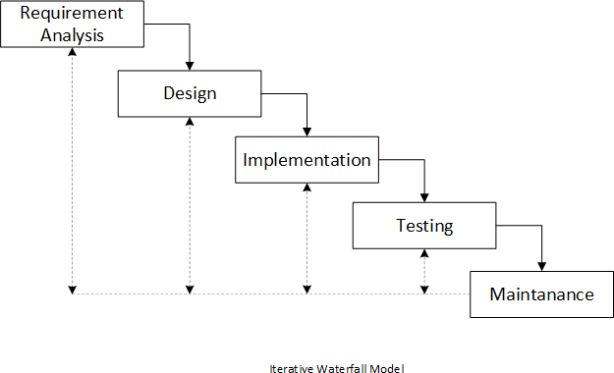

Fig 2.2.1

#### Phases of Iterative Waterfall Model

* + - 1. Requirement Analysis
      2. Software Design
      3. Implementation
      4. Testing
      5. Software Maintenance

#### Advantages of Iterative Waterfall Model

* The Iterative waterfall model is very easy to understand and use.
* Every phase contains a feedback path to its previous phase.
* This is a simple way to make changes or any modifications at any phase.
* By using this model, developers can complete projects earlier.
* Customer involvement is not required during software development.
* This model is suitable for large and complex projects.

#### Disadvantages of Iterative Waterfall Model

* There is no feedback path for the feasibility study phase.
* This model is not suitable if requirements are not clear.
* It can be costlier.
* There is no process for risk handling.
* Customers can view the final project, no prototype for taking customer review.
* This model does not work well for short projects.
* If modifications are required repeatedly then it can be more complex projects.

#### Project Plan

In managing any project, the whole plan of the project is made before its actual implementation. The plan of the project helps the team to work as per the schedule and helps to successfully complete the project.

To plan a project the main requirements that are calculated are cost, duration, effort, scheduling, manpower, resource allocation, risk management etc. The plan of our project is as follows:

| **Task** | **Duration** |
| --- | --- |
| Requirement And Analysis | 14 days |
| Design | 7 days |
| Development | 48 days |
| Testing | 7 days |
| Maintenance | 7 days |

Table 2.2.2 Project Plan Chart

#### Roles and Responsibility

| **Name** | **Analysis** | **Designing of UI** | **Coding for UI** | **API and Database** | **Testing** | **Documentation** |
| --- | --- | --- | --- | --- | --- | --- |
| Preet | ✔ | ✔ | ✔ |  |  | ✔ |
| Vivek | ✔ |  |  | ✔ | ✔ | ✔ |

Table 2.2.3 Roles and Responsibility

## SYSTEM REQUIREMENTS STUDY

### PROBLEMS AND WEAKNESSES OF CURRENT SYSTEM

The following Problems exist in current system,

* + - High Internet connectivity : It is streaming data so we required high internet connectivity for watch shows without buffering.
    - Time consuming: we have to fetch data of movies from database due to it every procedure becomes time consuming
    - Moreover, some of the applications are not user friendly. So we decided to develop a user-friendly application that is based on basic and important features like search shows, comment shows,add to list and add to favorite list etc.

### USER CHARACTERISTICS

The users will primarily be the team members who want to watch shows and entertain themselves and other users are the normal people who want to watch movies according to their desire.

### HARDWARE/SOFTWARE REQUIREMENTS

#### Software requirements

* + MongoDb, Node S, Express, React.JS.

#### Suitable Hardware requirements

* + Any device with 4gb RAM and 20 GB storage space.

SYSTEM REQUIREMENTS STUDY

### CONSTRAINTS

#### Hardware Limitations

There is only one limitation of this application, that is it will work only on a web-based system.

#### Interface to other applications

There are no other systems that use this application as an interface.

#### Reliability Requirements

The application must adhere to the reliability requirements as needed and should run smoothly. It must show real time data.

#### Criticality of the Application

The application does not respond if there is any server unavailability.

### ASSUMPTIONS AND DEPENDENCIES

* + - Users have sufficient privileges to access the internet.
    - All Servers are running smoothly.

## SYSTEM ANALYSIS

### REQUIREMENTS OF NEW SYSTEM

#### User Requirements

User requirements are:

* + - * Users can watch movies without downloading them.
      * Users can add movies to their favorite list or in their watch list .
      * Users can watch all shows like movies , TV shows etc.
      * Users can see details like tag , description , rating.
      * Users can also see movie suggestions according to which movie they are watching.

#### System Requirements

1. **Functional Requirements**

**R1 For User**

**R1.1 Sign-Up**:-

Input : email , password , name.

Output: Sign up successful and email send account verify

**R1.2 Sign-In :-**

Input : email , password .

Output: Token , user’s data and sign in successful

**R1.3 Update-Password :-**

Input : password, new Password.

Output: password updated successfully

**R1.4 Get User Data**

Input : user id.

Output: user’s data in Json format.

**R1.5 Verify User**

Input : user id.

Output: user verified and send message user account verified successfully

**R2 For Favorite**

**R2.1 Add Favorite :**-

Input : user id, media id.

Output: data which is saved in favorite in Json format.

**R2.2 Remove Favorite :-**

Input : favorite id.

Output: favorite media deleted successfully

**R2.3 Get Favorite :**-

Input : user id.

Output: data of favorite media list is sorted according to which is first added.

**R3 For Review**

**R3.1 Add Review :-**

Input : media id.

Output: data which is saved in review in Json format.

**R3.2 Remove Review :-**

Input : review id.

Output: review deleted successfully

**R3.3 Get Review :**-

Input : user id.

Output: data of review list is sorted according to which is first added.

**R4 For Review**

**R4.1 Get Review :-**

Input : media type , media category.

Output: data of media list in Json format.

**R3.2 Get Details :-**

Input : media type , media id.

Output: data with media credits , videos , recommend,images , is favorite and review in

Json format.

**R3.3 Search :**-

Input : actor name or show name.

Output: data of media list which relate with search in Json format.

#### Non-functional Requirements

* 1. Security

Security is the primary requirement of any system. This platform must maintain/process data in a secure way so unauthorized entities do not have illegal access to it.

* 1. Performance

Performance requirements define how well the system performs certain functions under specific conditions. Examples are speed of response, throughput, execution time and storage capacity. Like most quality

attributes, performance requirements are key elements when designing and testing the product. This platform should be designed in such a way that its performance is smooth for users.

* 1. Scalability

Scalability is a property of a system that describes the ability to appropriately handle increasing (and decreasing) workloads. Scalability competes with and complements other non-functional requirements such as availability, reliability, and performance. This platform must be designed in such a way that it is able to scale well with increasing/decreasing accesses, users etc.

* 1. Availability

System must be available to authorized users when it is required. This platform must be designed in such a way that it is always available to authorized users and should handle abnormal scenarios well by displaying proper messages to users. In any abnormal situations, user’s data should not be lost.

### ER DIAGRAM

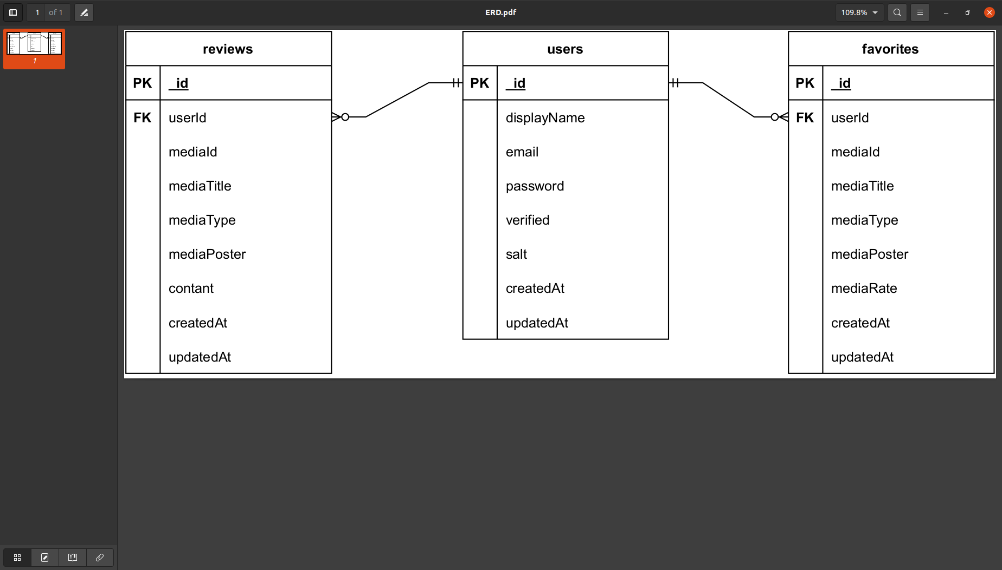

ER Diagram

Fig 4.2.1

### DFD

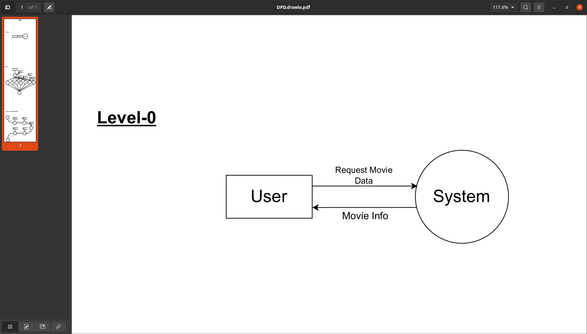

Level 0 - Data Flow Diagram

Fig 4.3.1

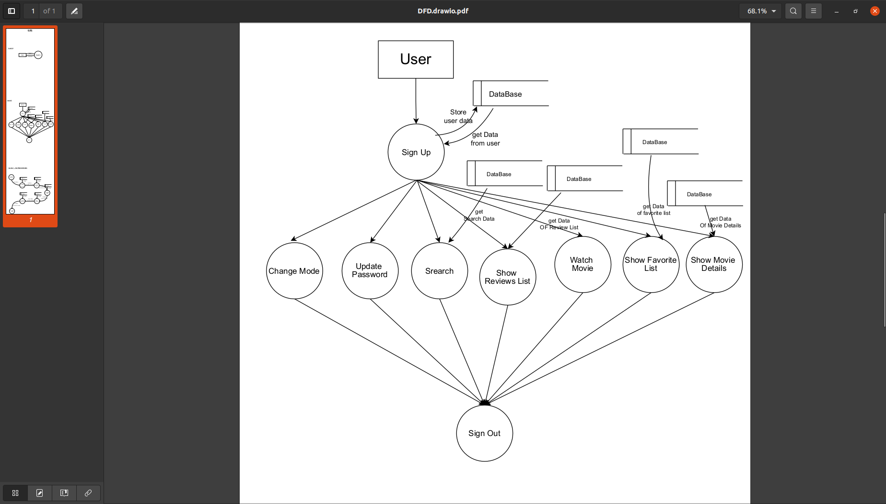

Level 1 - Data Flow Diagram

Fig 4.3.3

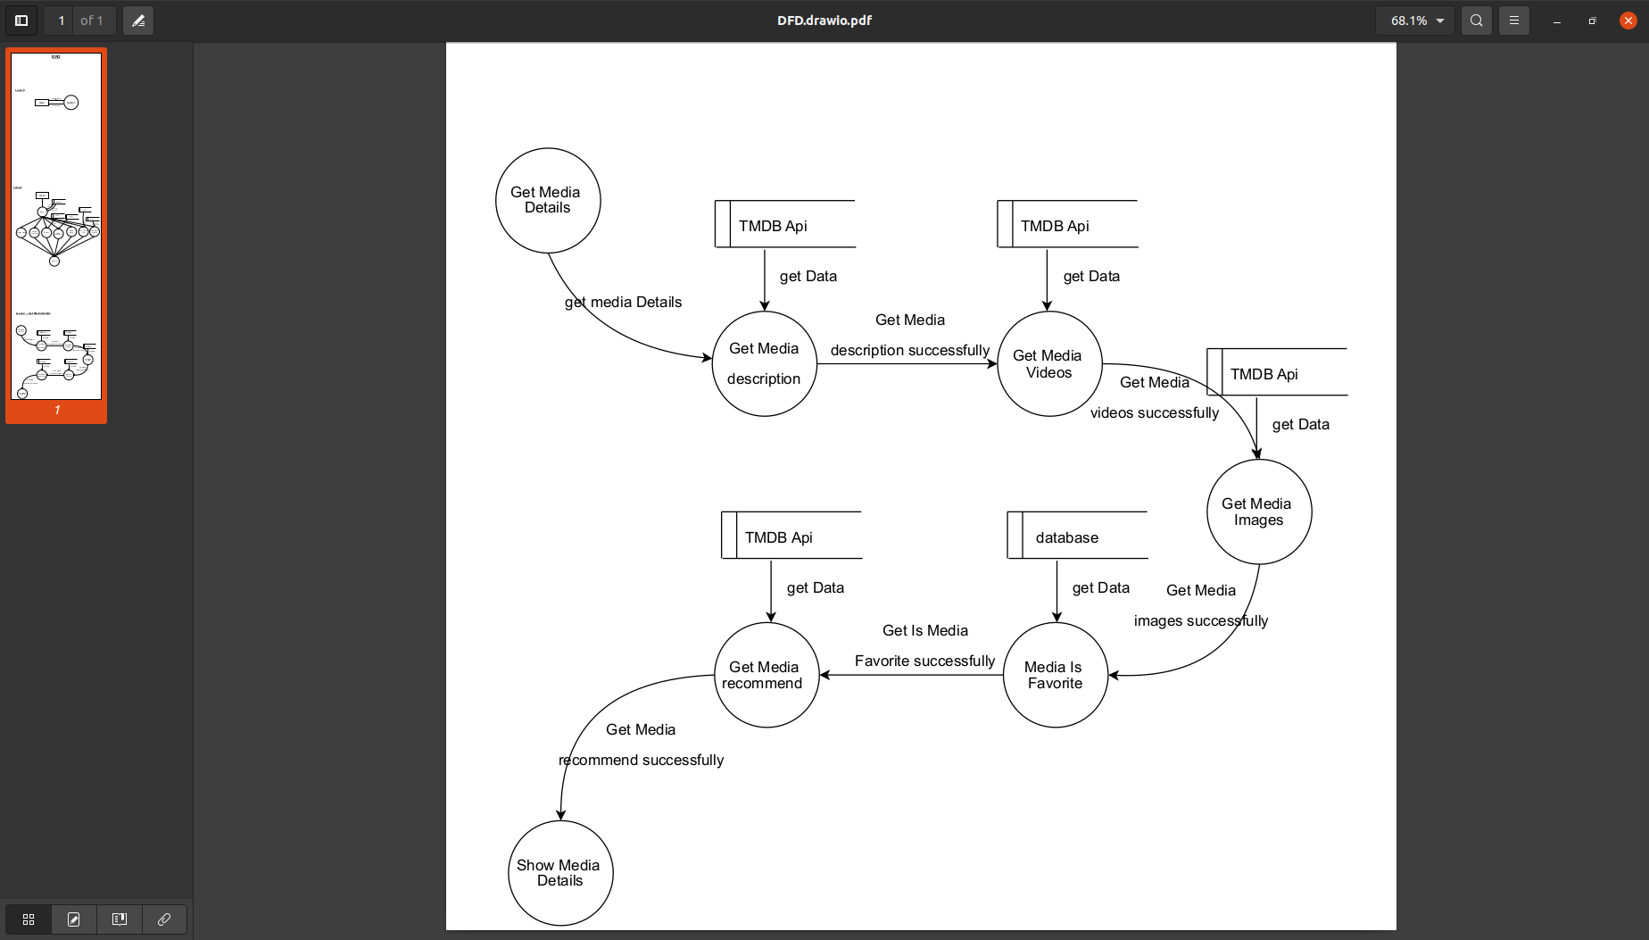

Level 2 - Data Flow Diagram (Get Media Details)

Fig 4.3.3

## SYSTEM DESIGN

### USE CASE DIAGRAM

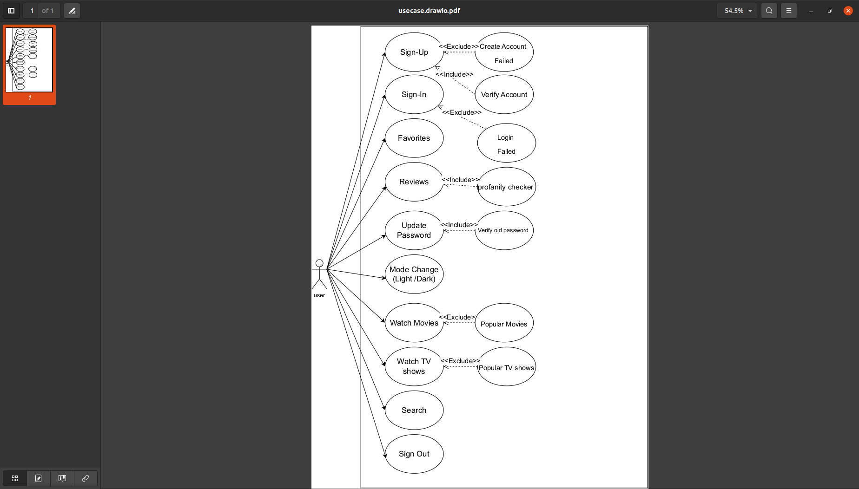

Use case Diagram

Fig 5.1.1

### SEQUENCE DIAGRAM

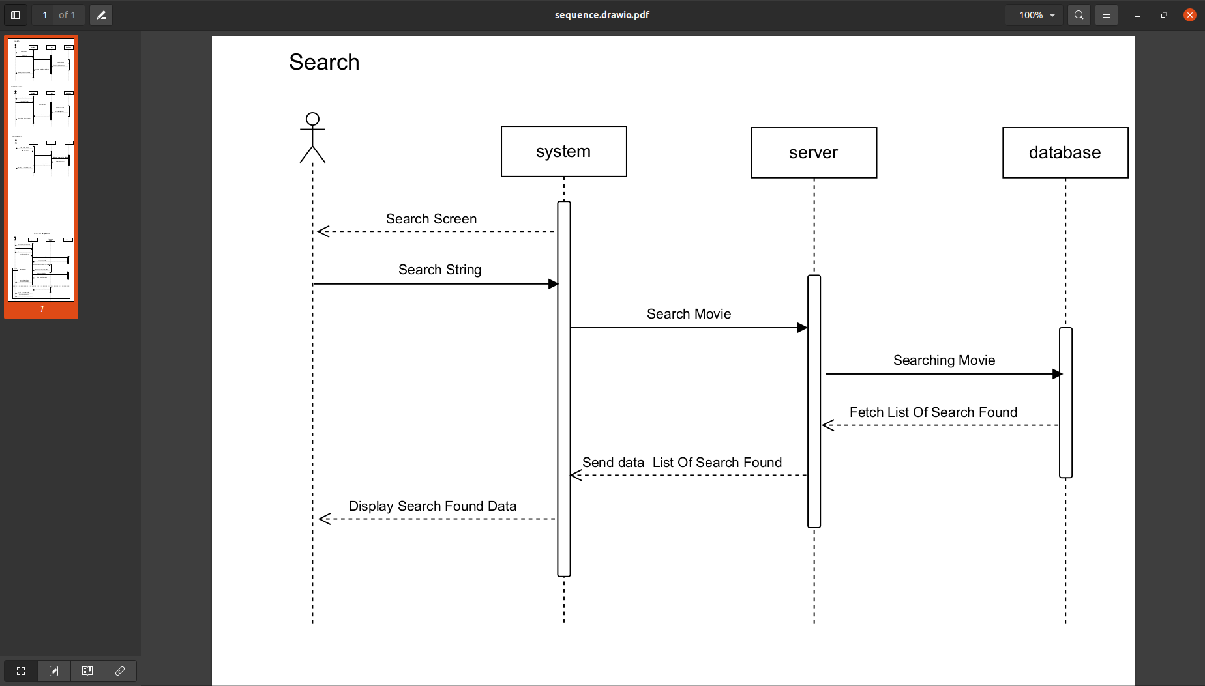

Sequence Diagram - Search

Fig 5.2.1

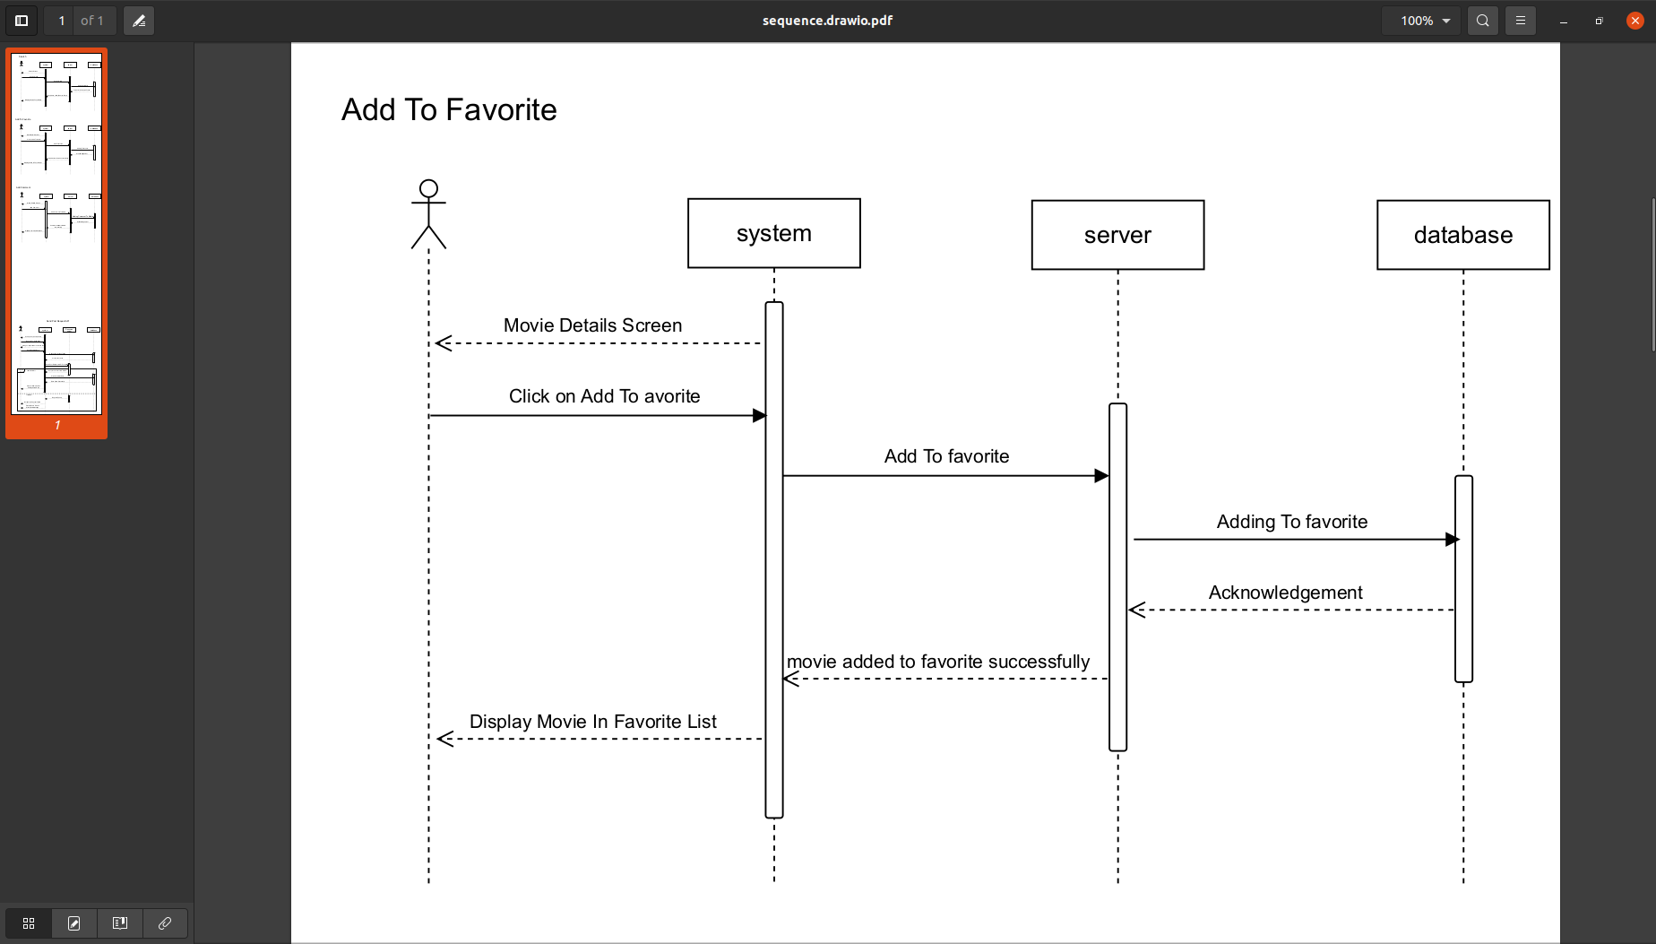

Sequence Diagram - Add to Favorite

Fig 5.2.2

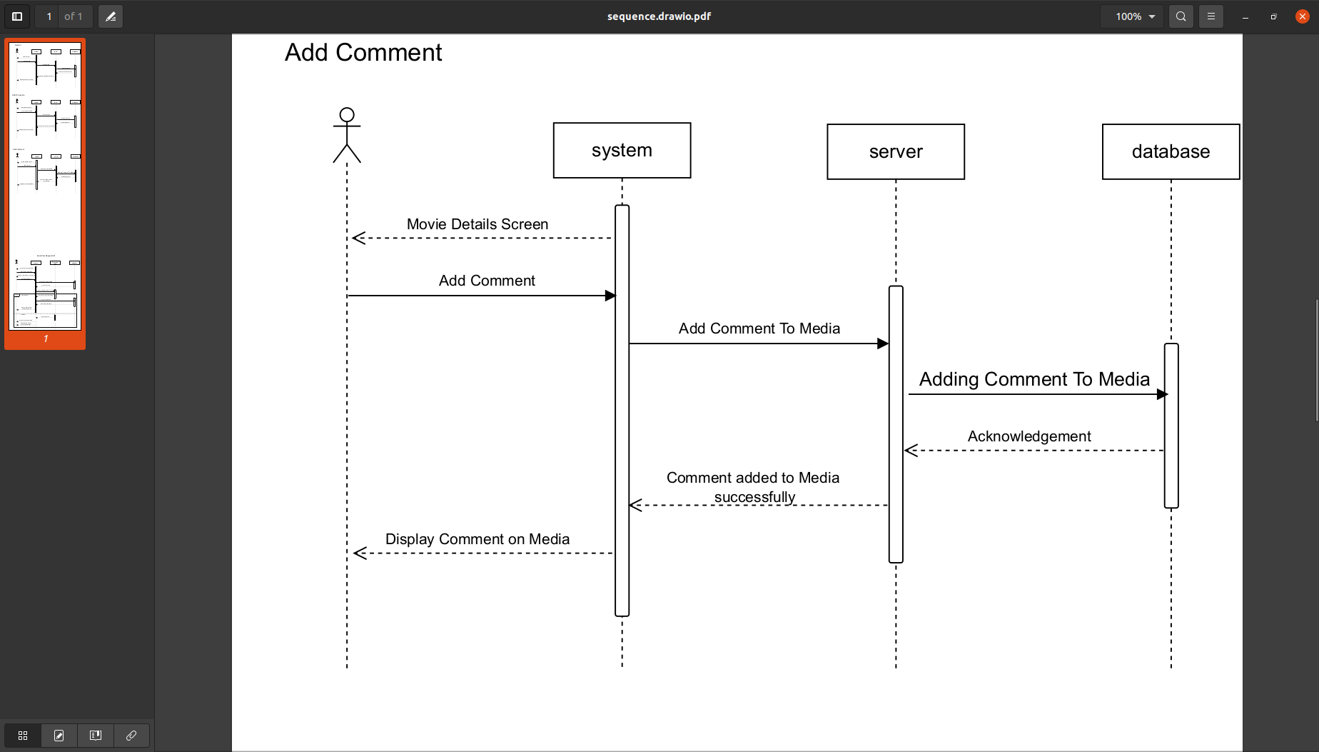

Sequence Diagram - Add Comment

Fig 5.2.3

### ACTIVITY DIAGRAM

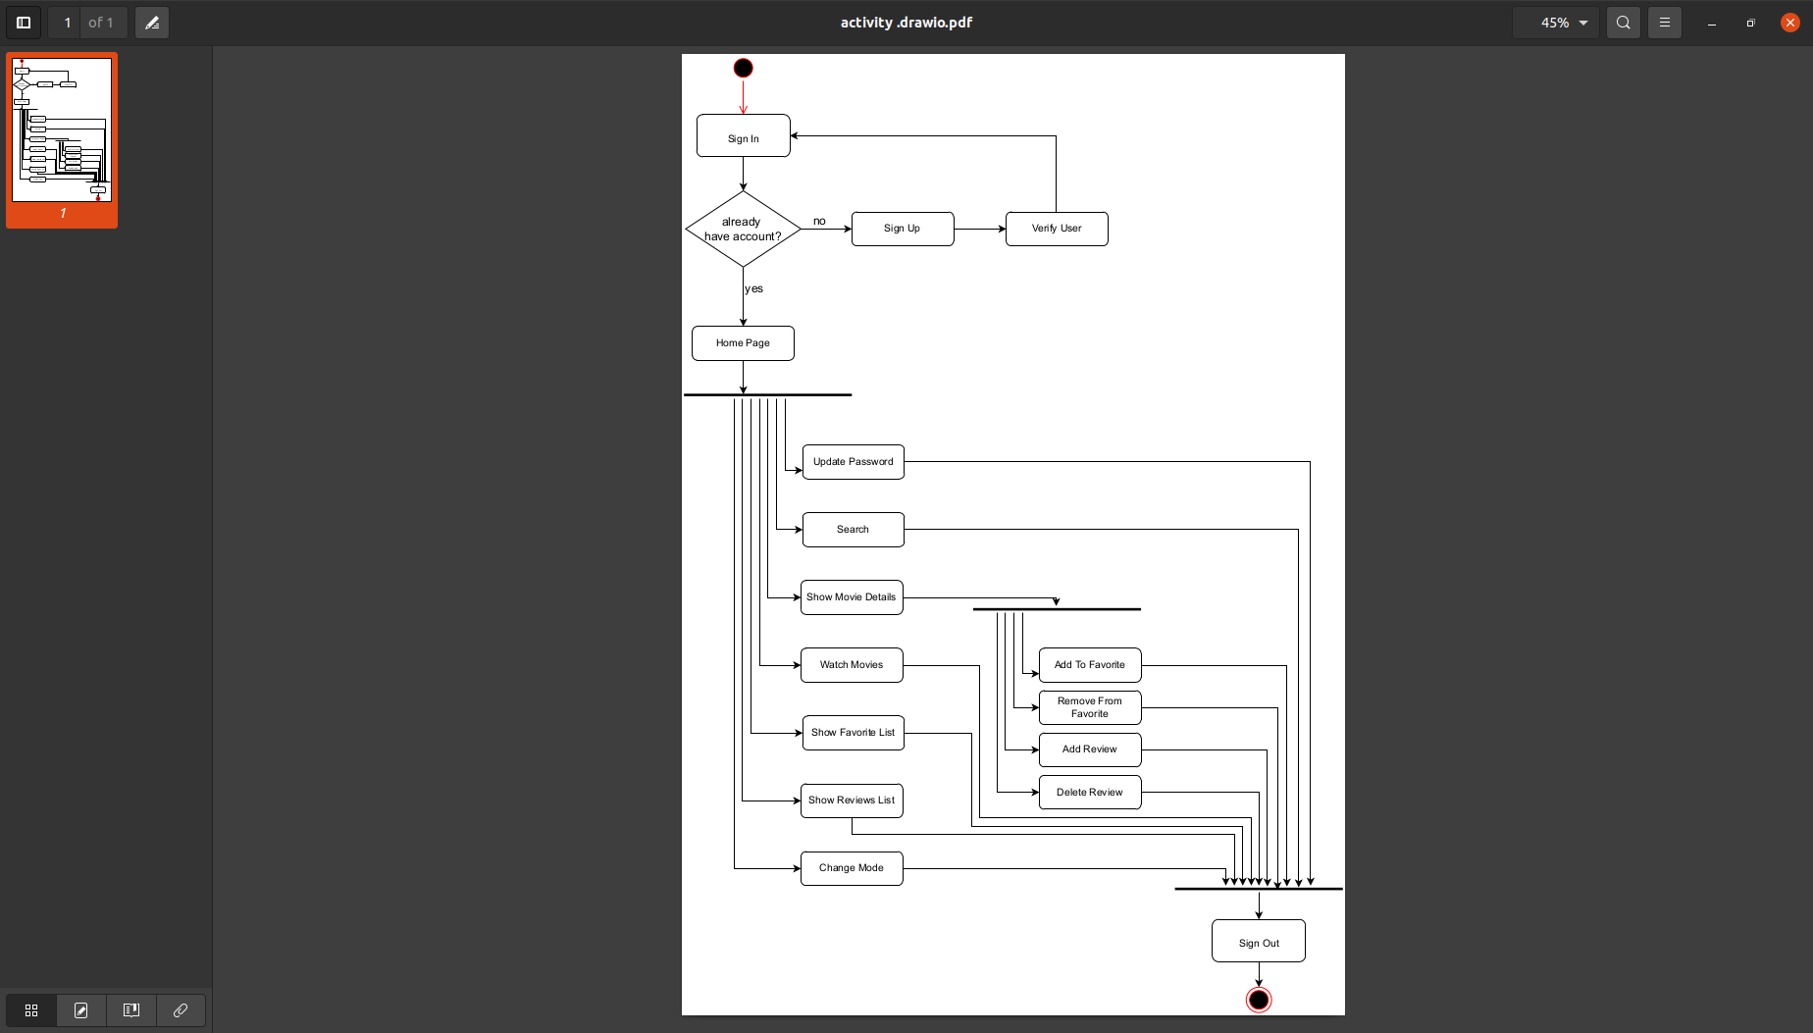

Activity Diagram

Fig 5.3.1

### DATABASE DESIGN:

Following database is designed by us for demonstration purposes only. The actual database design is different from this and is not shared in this report for security purposes.

**Database Tables**

**users**

| **Attribute** | **Data Type** | **Constraint** | **Description** |
| --- | --- | --- | --- |
| _id | ObjectId | Unique | User Id |
| displayName | String | Not NULL | User Name |
| email | String | Not NULL | User Email |
| password | String | Not NULL | User Password |
| verified | Boolean | Not NULL | Is User Account Verified |
| salt | String | Not NULL | Safeguard Passwords in storage |
| createdAt | Date | Not NULL | Date & Time when User Created |
| updatedAt | Date | Not NULL | Date & Time when User Data Updated |

#### favorites

| **Attribute** | **Data Type** | **Constraint** | **Description** |
| --- | --- | --- | --- |
| _id | ObjectId | Unique | Favorites Id |
| userId | ObjectId | Not NULL | User Id |
| mediaId | String | Not NULL | Media Id |
| mediaTitle | String | Not NULL | Media Title |
| mediaType | String | Not NULL | Media Type |
| mediaPoster | String | Not NULL | Posters of Media |
| mediaRate | String | Not NULL | Rating of Media |
| createdAt | Date | Not NULL | Date & Time when Favorite Created |
| updatedAt | Date | Not NULL | Date & Time when Favorite Data Updated |

**reviews**

| **Attribute** | **Data Type** | **Constraint** | **Description** |
| --- | --- | --- | --- |
| _id | ObjectId | Unique | Review Id |
| userId | ObjectId | Not NULL | User Id |
| mediaId | String | Not NULL | Media Id |
| mediaTitle | String | Not NULL | Media Title |
| mediaType | String | Not NULL | Media Type |
| mediaPoster | String | Not NULL | Posters of Media |
| content | String | Not NULL | Comment on the Movie. |
| createdAt | Date | Not NULL | Date & Time when Favorite Created |
| updatedAt | Date | Not NULL | Date & Time when Favorite Data Updated |

## IMPLEMENTATION PLANNING

### IMPLEMENTATION ENVIRONMENT

The application is a single user system with GUI. For the implementation of the project, we will need following as basic platforms and tools:

* + - MongoDB- This Software used for storing data in object format.
    - Visual Studio Code- This IDE used for front-end and back-end related work.
    - Postman- This software is used for API testing.

We are using tech. like JavaScript, React-App and Node Js Library, React Js Library , express ,MongoDB.

### PROGRAMS AND MODULES SPECIFICATION

Our application mainly divides into two parts:

#### Front-end:

* + - * UI Design
      * UI Implementation.
      * Get Data From api & Represent to Client.

#### Back-end:

* + - * Create Api.
      * Take Data From Front-end And Create & Update Database.
      * Fetch Data From Database For Front-end Requirement.

IMPLEMENTATION PLANNING

### CODING STANDARDS

To make the system coding easy, easy to remember and reducing the chances of errors some techniques are used at the time of coding of the application which is called coding standard. The coding standard which we adopted during the coding is explained as follows:

* + - Each nested block should be properly indented and spaced.
    - The code should be properly commented for understanding easily.
    - Comments regarding the statements increase the understandability of the code.
    - Better to avoid use of digits in variable names.
    - The names of the function should be written in camel case starting with small letters.
    - The name of the function must describe the reason for using the function clearly and briefly.

## TESTING

### TESTING PLAN

The testing technique that is going to be used in the project is White box testing. In White box testing the Tester has knowledge about the internal structure of the code or the program of the software.

#### White Box Testing:

It is software testing technique in which internal structure, design and coding of software are tested to verify flow of input-output and to improve design, usability, and security

Out of the 2 methods for testing, black box testing and white box testing, we would be using the white box testing as we are well aware of the internal functionalities of our application unlike in the black box testing

### TESTING STRATEGY

The development process repeats this testing subprocess a number of times for the following phases.

* + 1. Unit Testing: It ensures that all code meets quality standards before it's deployed. Also, it detects software bugs earlier.
    2. Integration Testing: It tests whether the various programs that make up a system, interface with each other as desired, fit together and whether the interfaces between the programs are correct.

We also used below testing methods:

* Smoke testing: It is a software testing process that determines whether the deployed software build is stable or not. Smoke testing is a confirmation for the QA team to proceed with further software testing.
* Exploratory testing: It is suited for specific testing scenarios. While testing other scenarios, most of the bugs we find. It is often described as simultaneous learning, test design, and execution.
* Regression testing: Ensures that new coding doesn't interrupt existing coding features. Assures there are no defects or bugs after implementing software update

### TEST CASES

| **Entity** | **Test Case** | **Expected Output** | **Actual Output** | **Result** |
| --- | --- | --- | --- | --- |
| Sign-Up | Validation | Redirect To  Login Page | As Expected | pass |
| Sign-In | Validation | Redirect To Home Page | As Expected | pass |
| Update  Password | Validation | Password Updated Successfully | As Expected | pass |
| Get User Details | View Details | Show Details Of User | As Expected | pass |
| Verify User | Validation | User Verify Successfully. | As Expected | pass |
| Add To Favorite | Validation | Media Added In Favorite. | As Expected | pass |
| Remove From Favorite | Validation | Media Removed In Favorite. | As Expected | pass |
| Get Favorite List Of User | View Details | Display List Of All Favorite Medias. | As Expected | pass |
| Get Media List | View Details | Display List Of Media with Details | As Expected | pass |
| Get Genres List | View Details | Display List Of Genres with Details | As Expected | pass |
| Search | View Details | Display All Media Related To Search String | As Expected | pass |
| Get Media Details | View Details | Display Details Of Selected Media | As Expected | pass |
| Add Review | Validation | Review Added To That Media | As Expected | pass |
| Delete Review | Validation | Review Added From That Media | As Expected | pass |
| Get All Reviews | View Details | Display List Of All Favorite Medias. | As Expected | pass |

Table 7.4 Test Cases

## USER MANUAL

User Manuals are manuals that enable the user of a system or application to understand the working of the system and help them to use them efficiently. It is usually written by a technical writer, although user guides are written by programmers, productor project managers, or other technical staff, particularly in smaller companies.

### Sign In Page

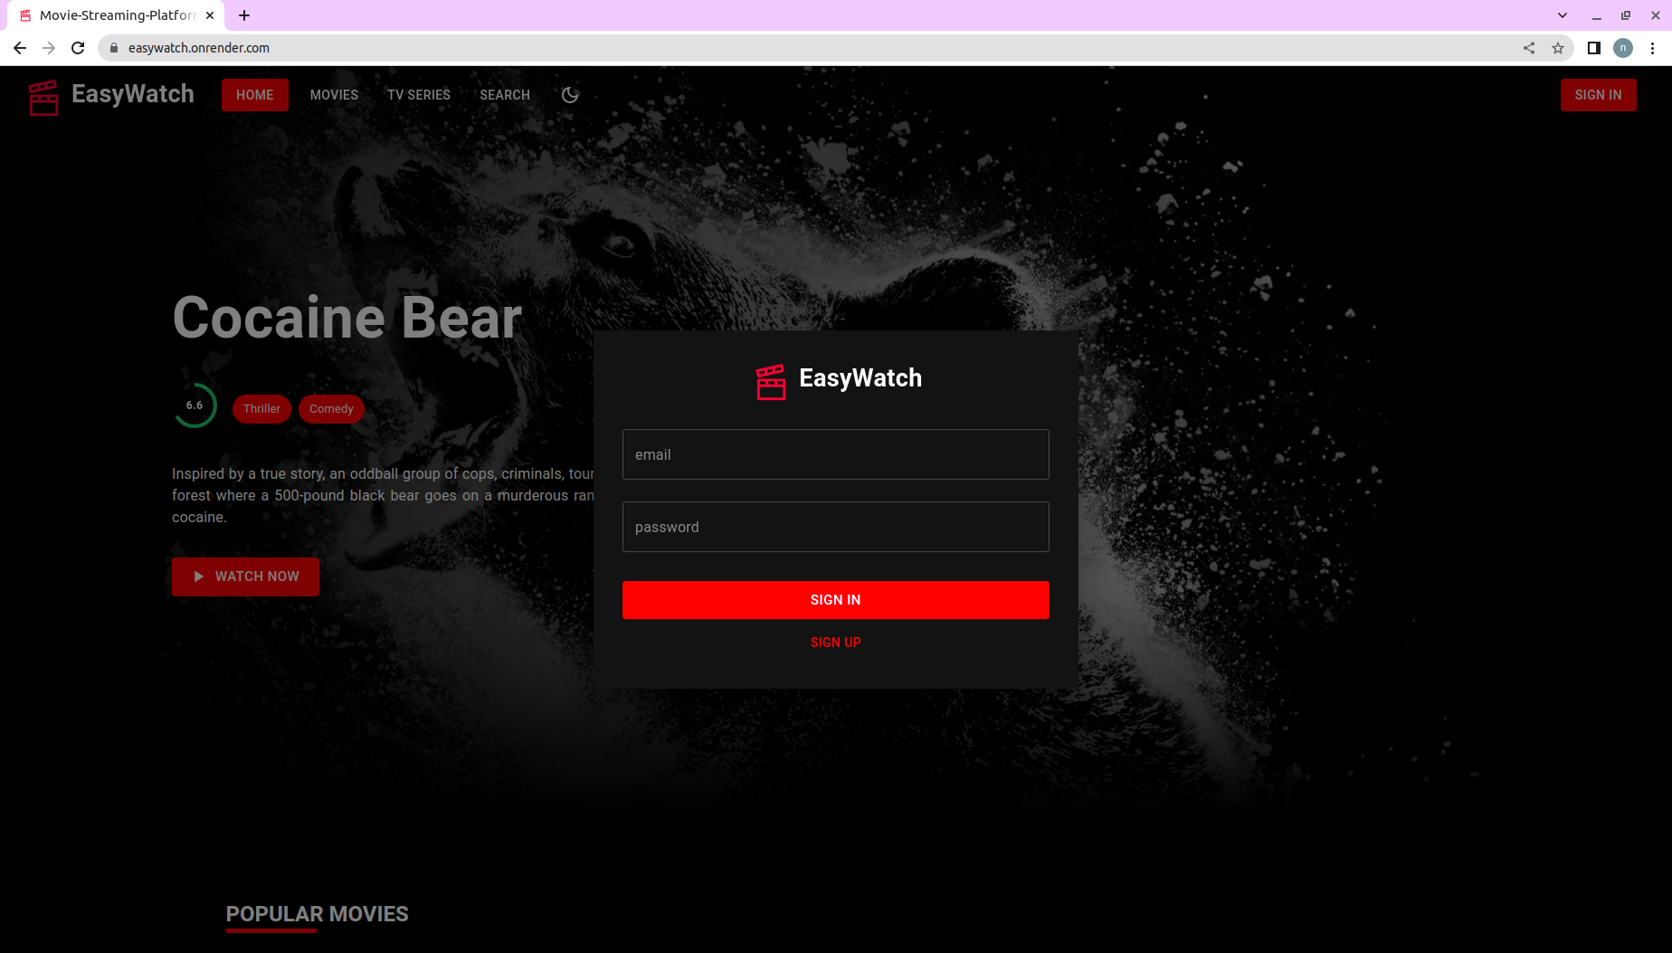

### Sign Up Page

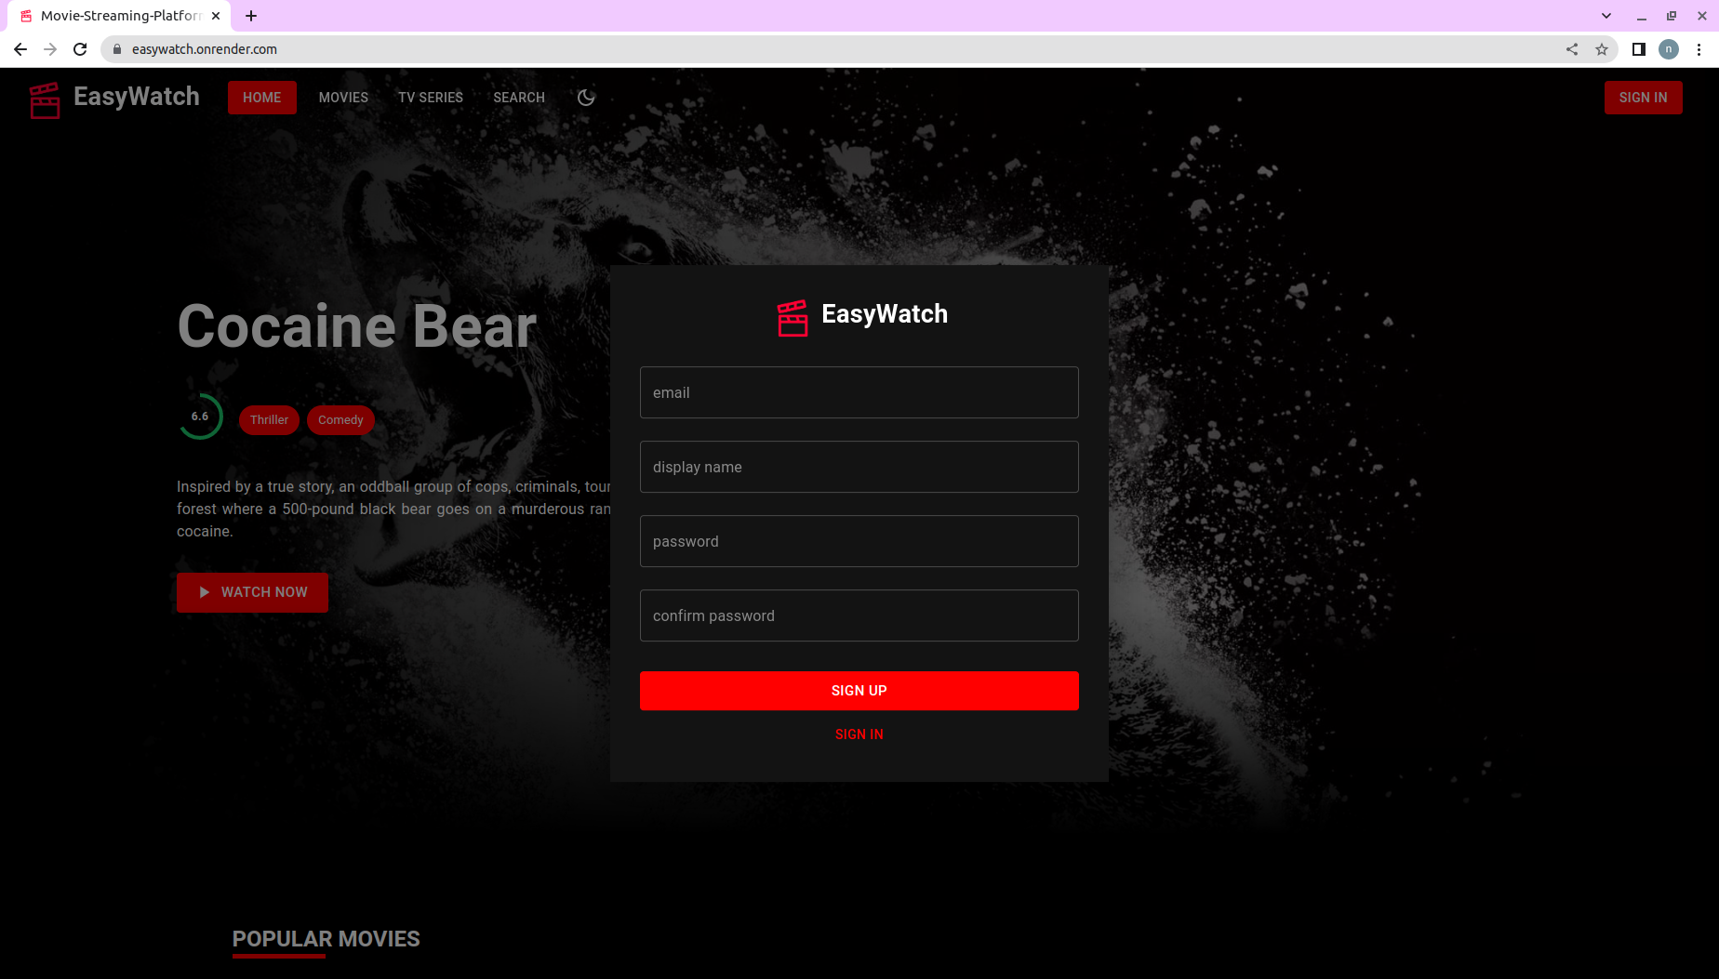

### User Verify Mail

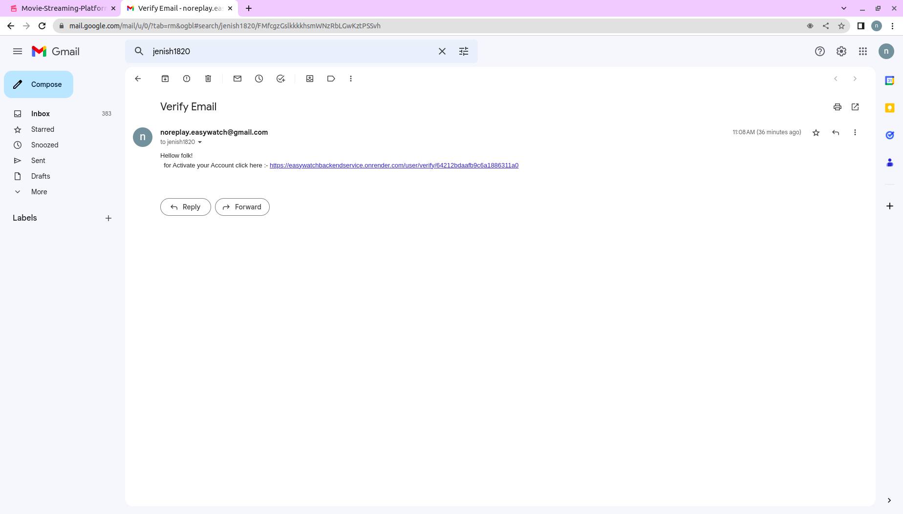

### Home Page

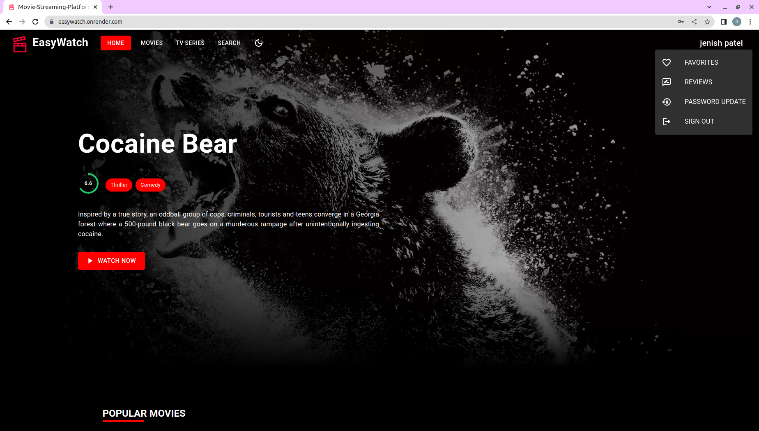

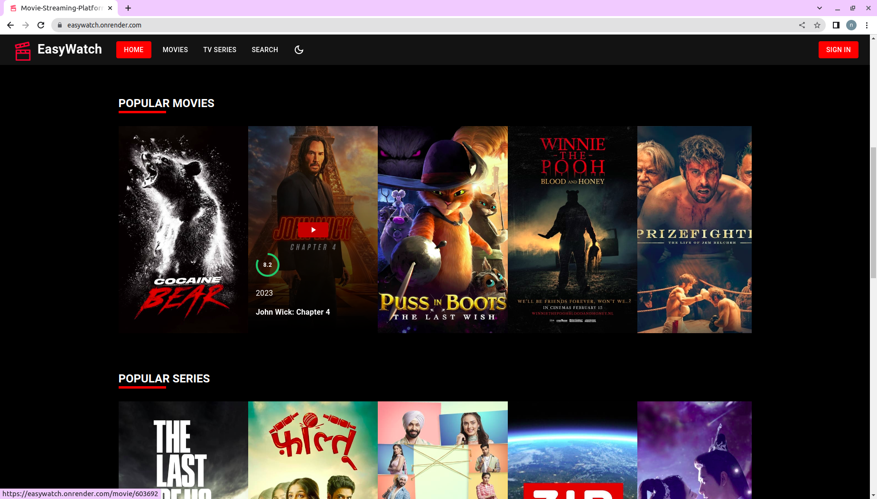

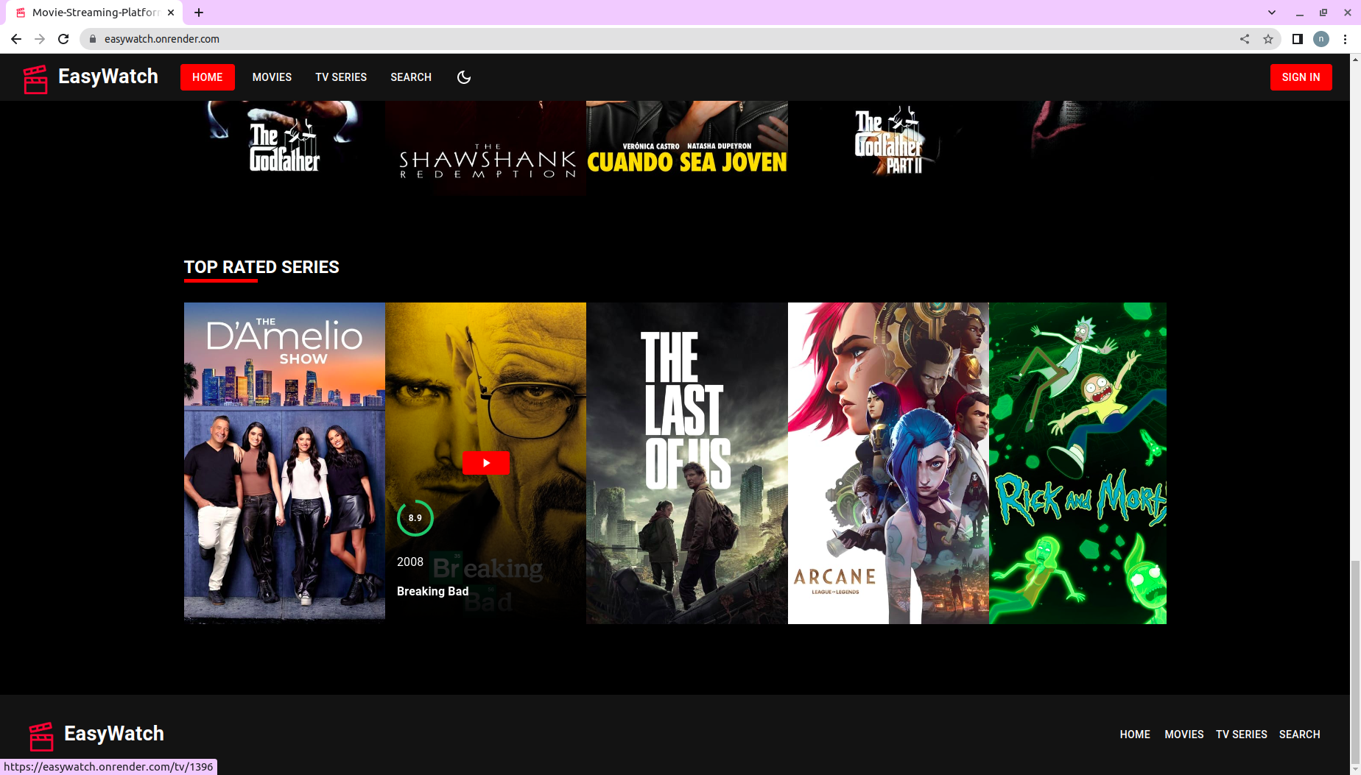

### TV Shows Page

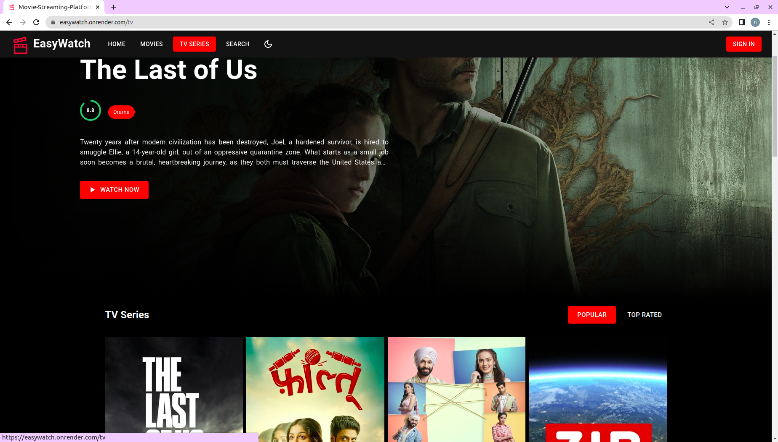

### Search Movie / TV Shows / Actor

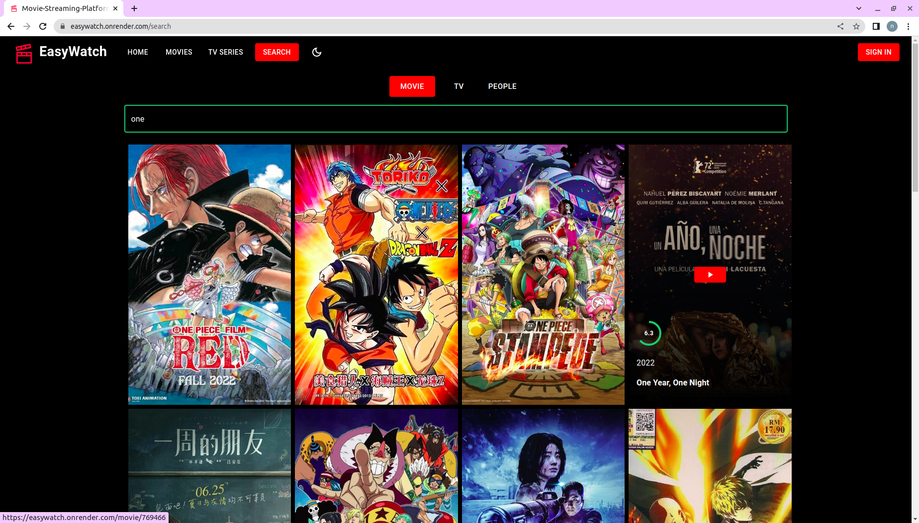

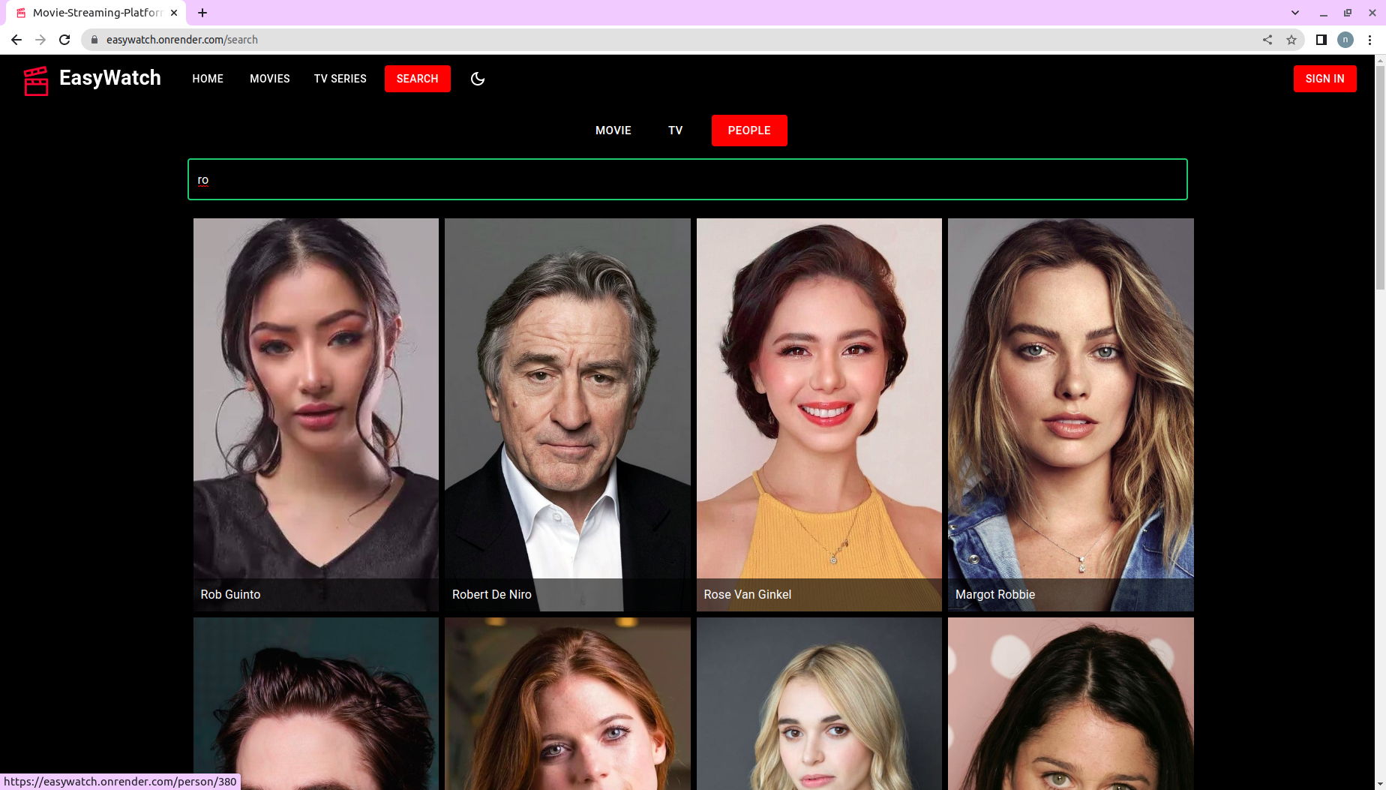

### 

### Dark / Light Mode Change

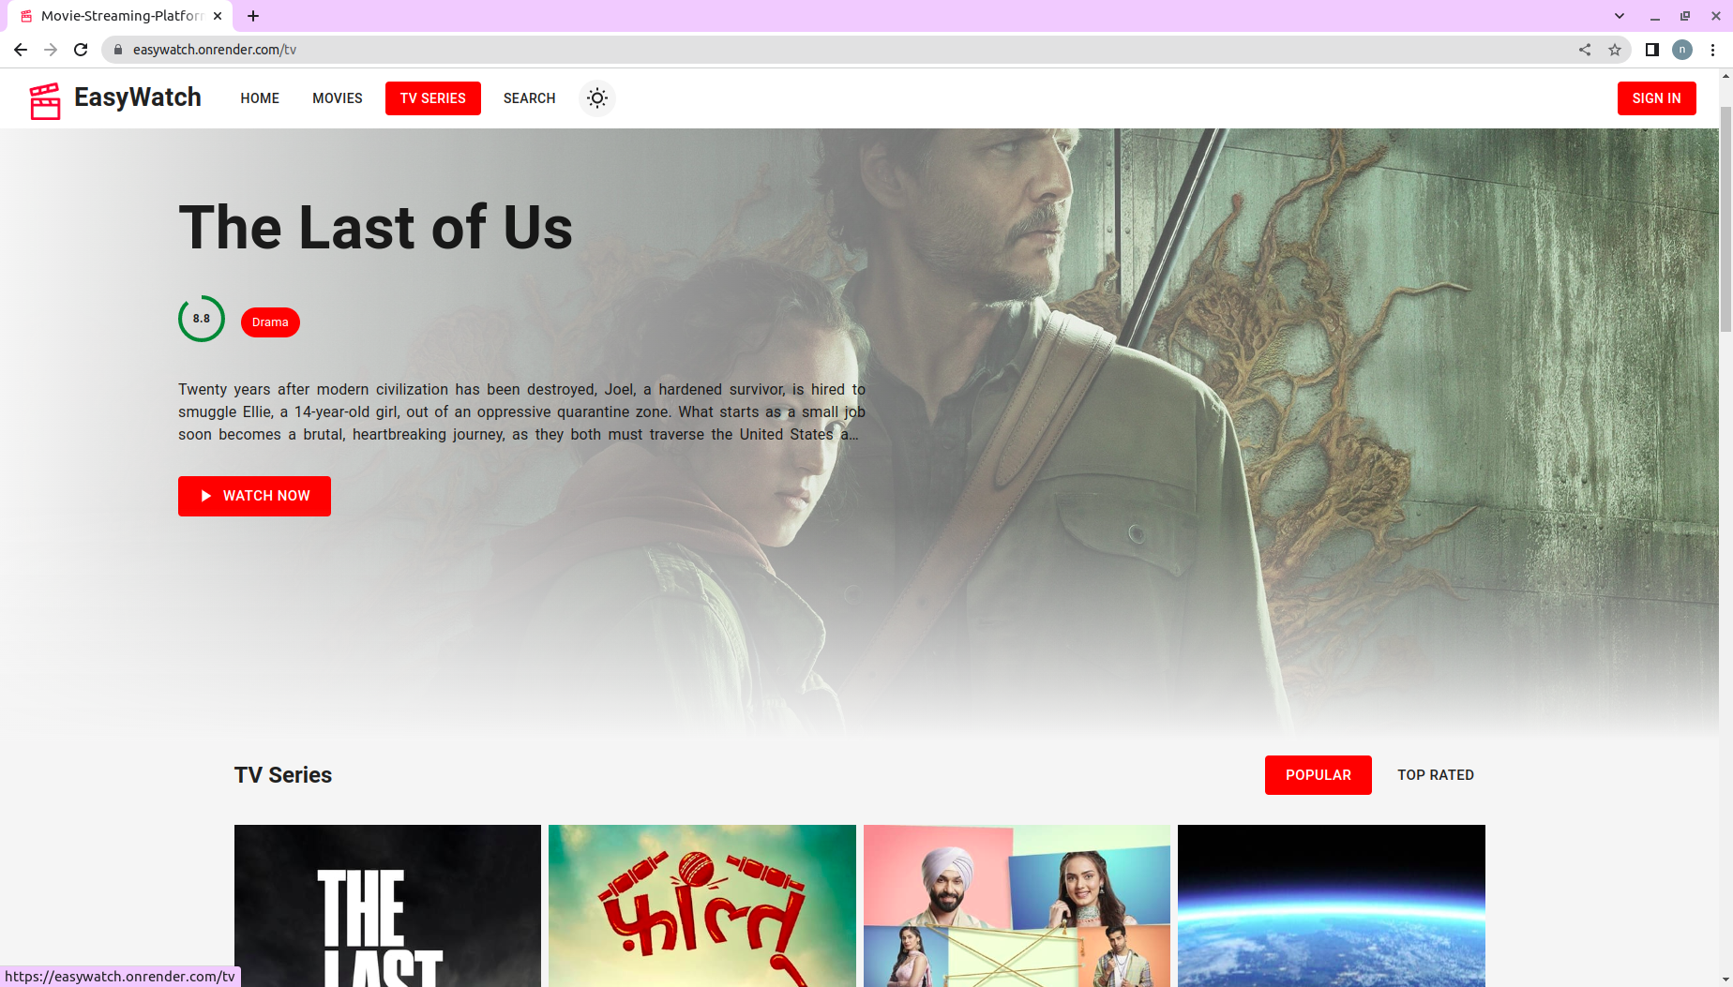

### Movie Details Page

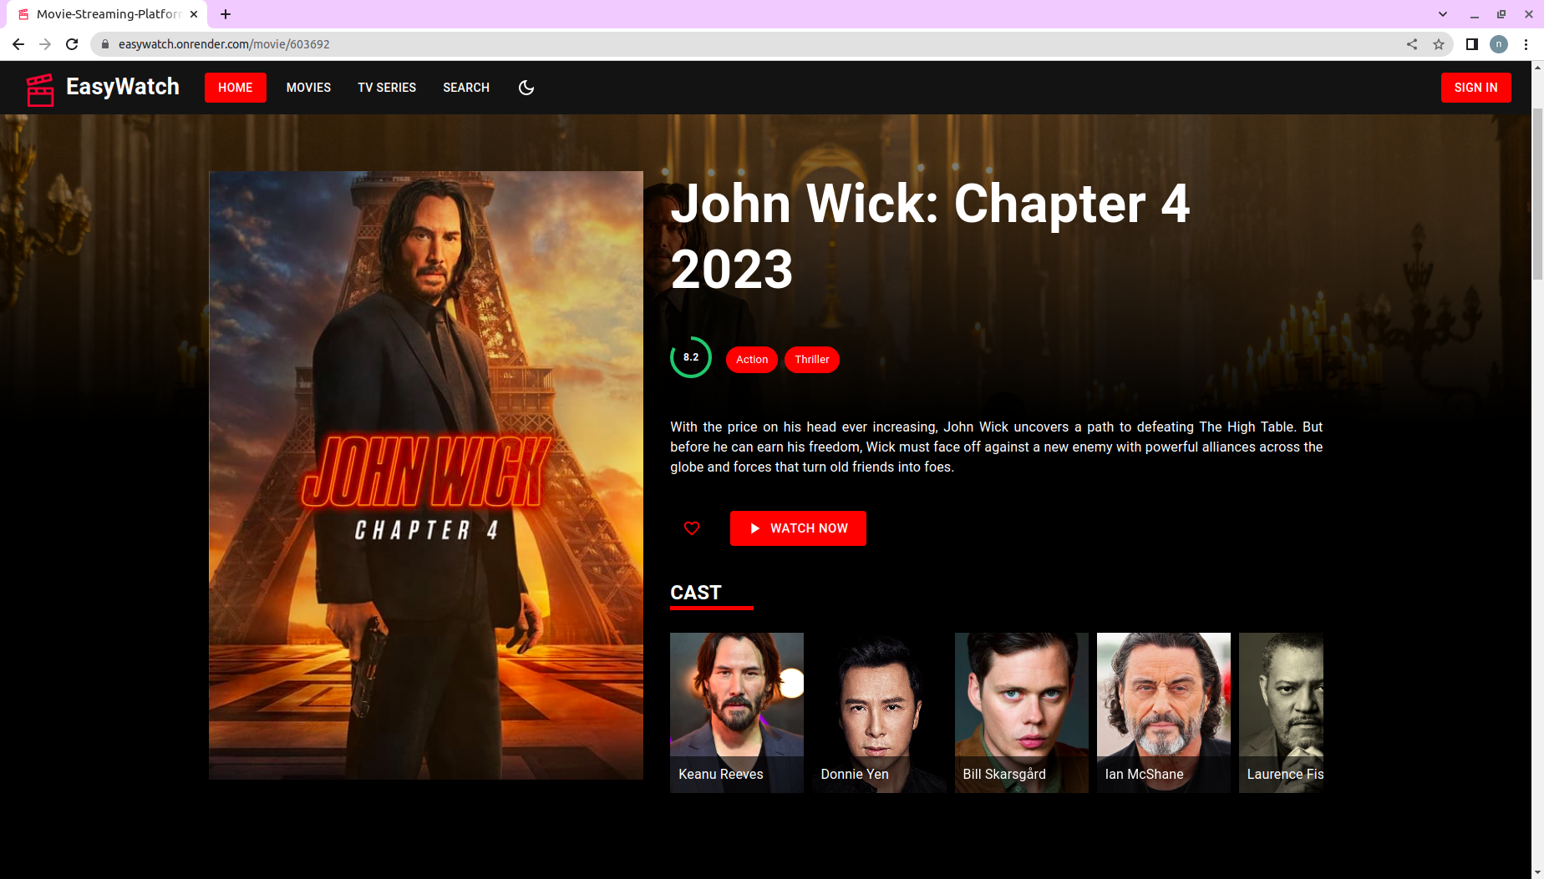

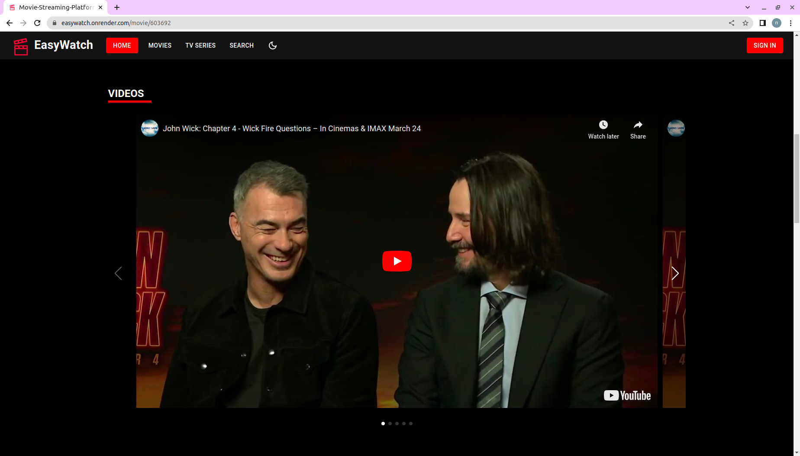

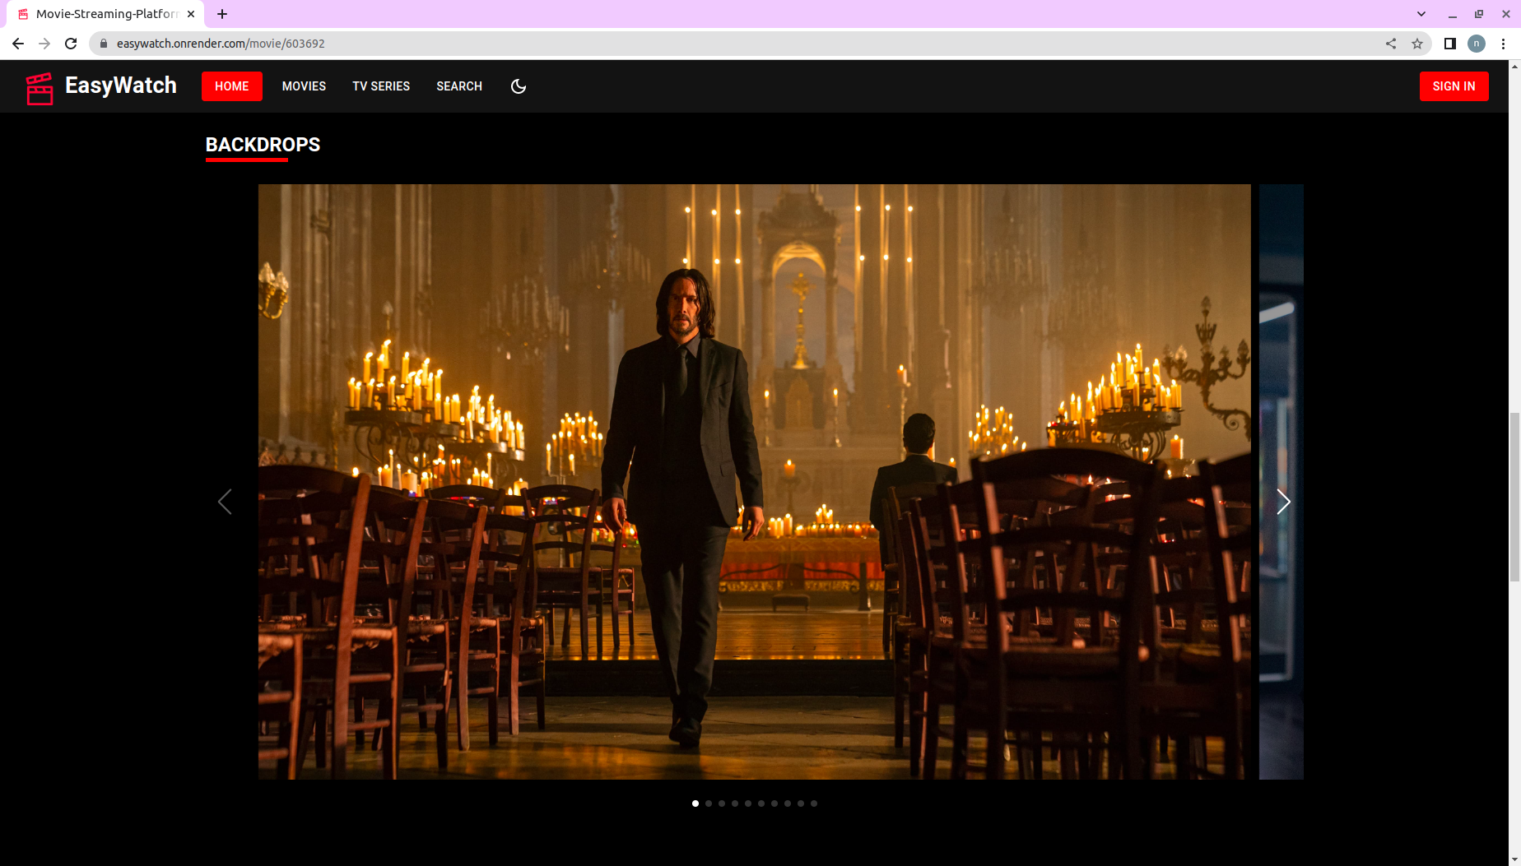

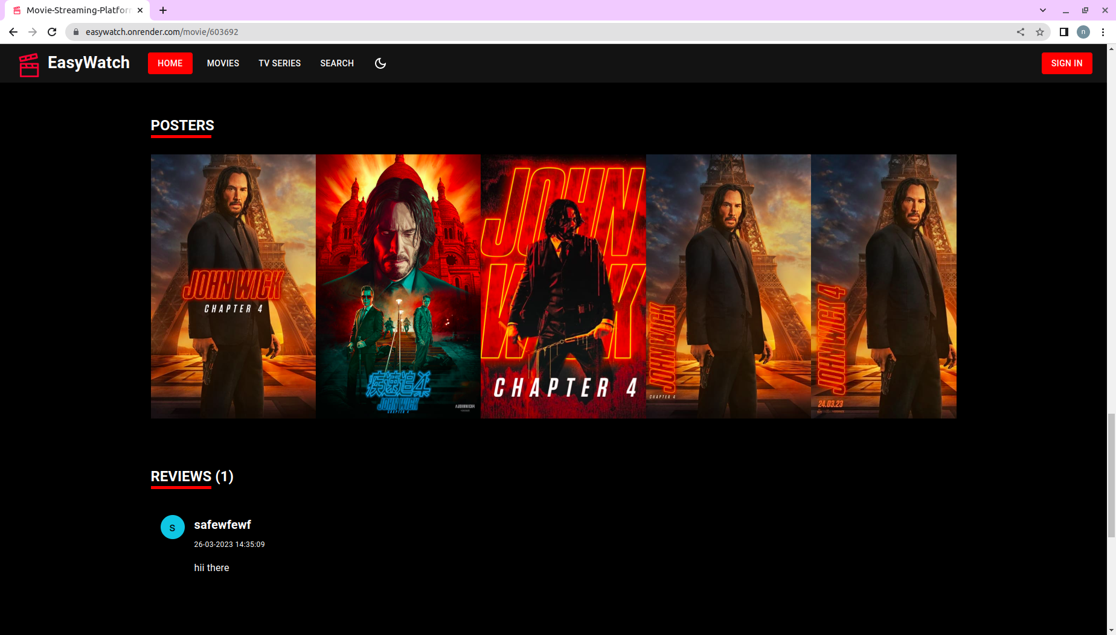

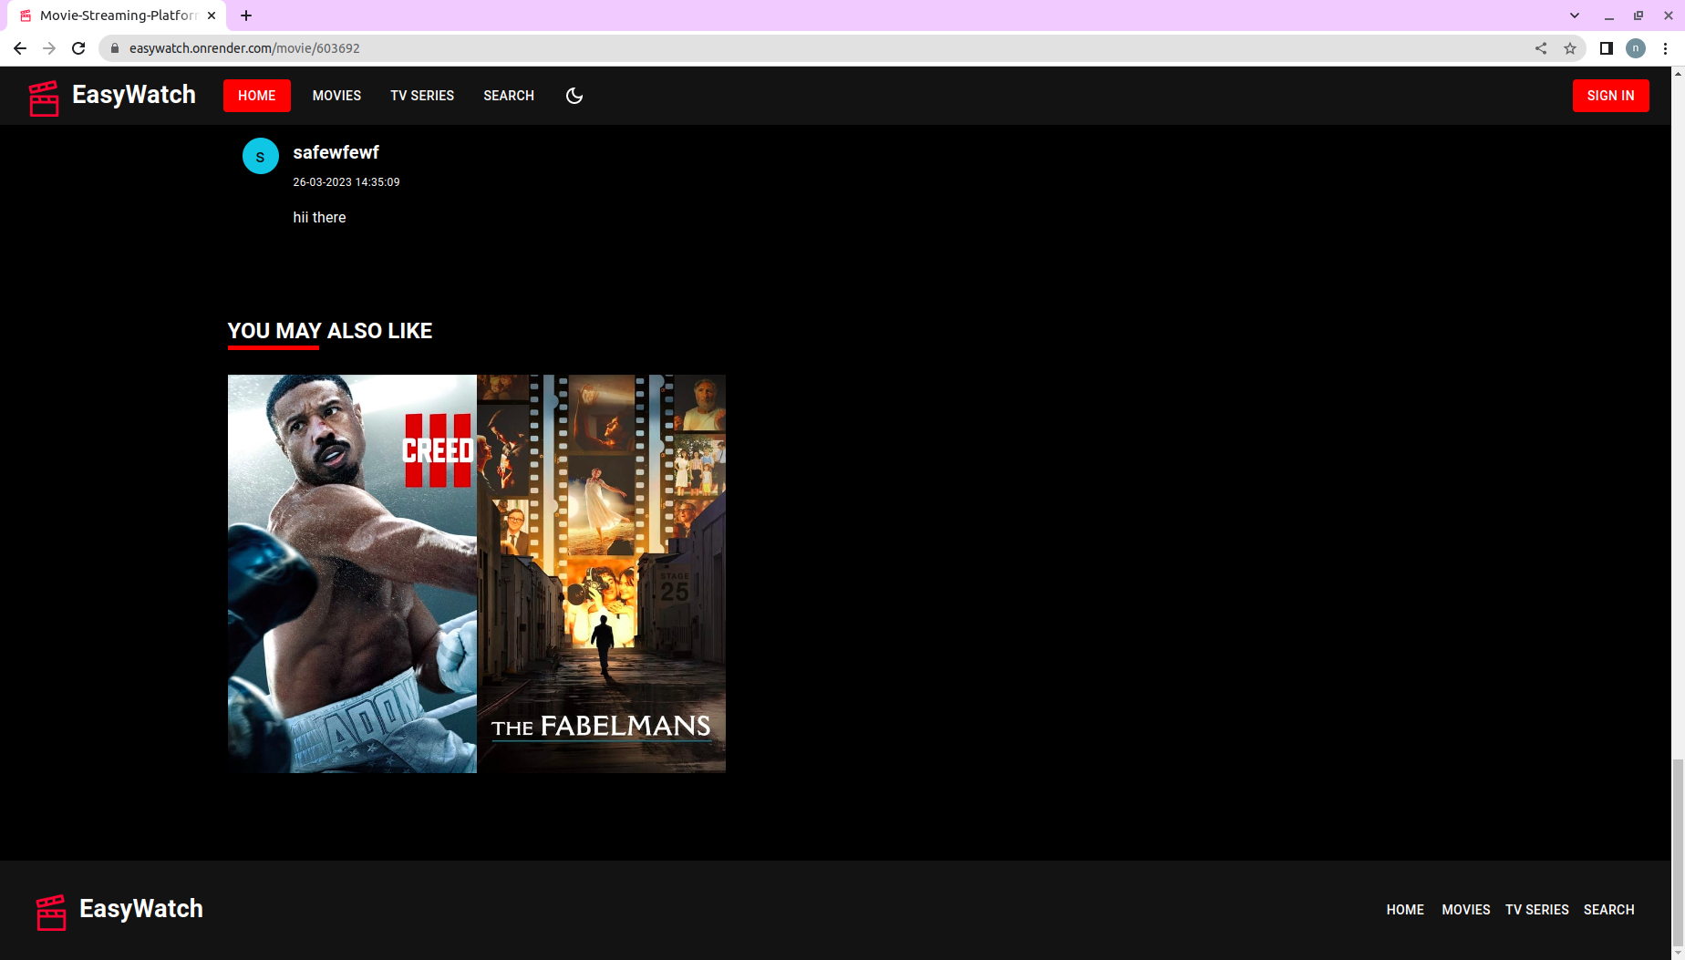

### Add Review

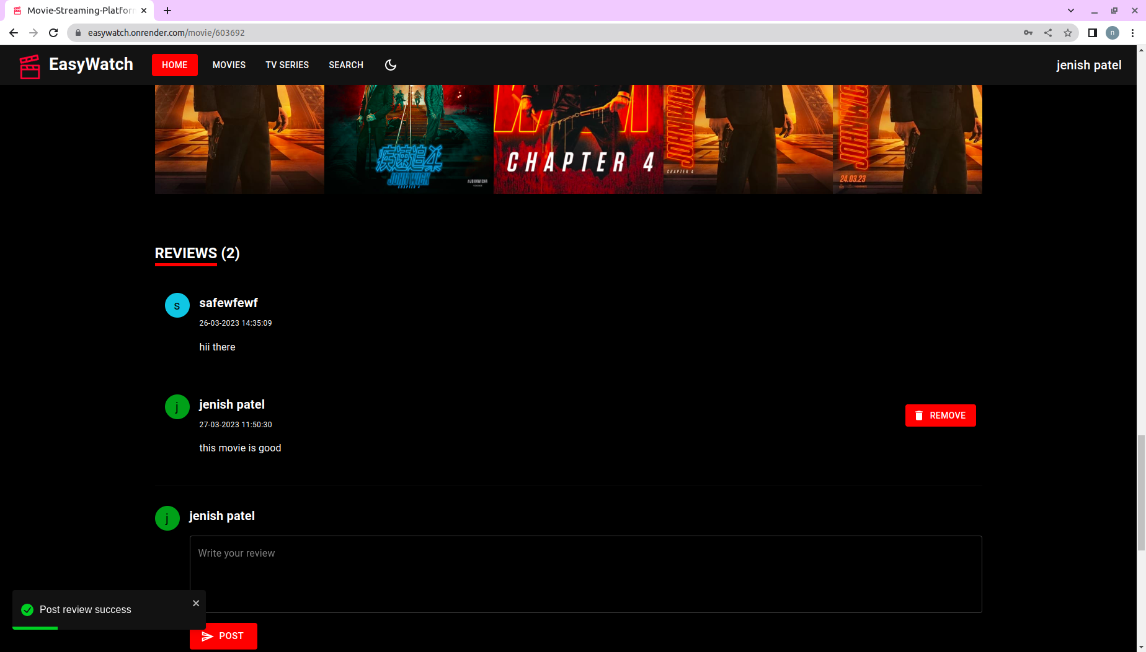

### Review List Page

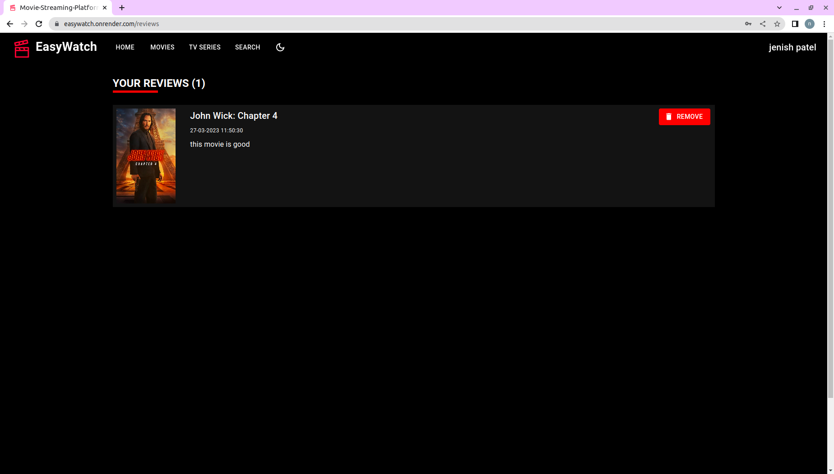

### Favorite List Page

### 

### 

### 

### Actor Details Page

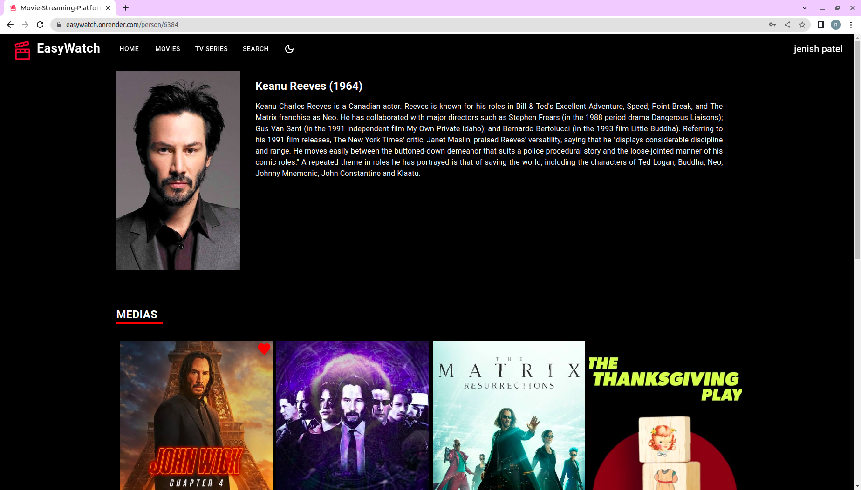

### Update PAssword Page

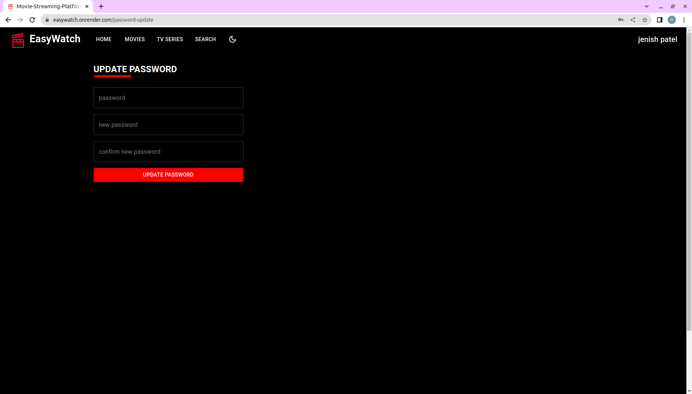

## LIMITATION AND FUTURE ENHANCEMENTS

### LIMITATION

* + - We are taking data from tmdb api. So ,this procedure is time consuming.
    - Users require a high internet connectivity .
    - We can’t recommend movies according to the user's age.

### FUTURE ENHANCEMENTS

* + - Store data of movies to our database. So , we can easily fetch it.
    - By optimizing code, Results will be generated much faster than this.
    - make a recommendation model for recommending movies to users according to their age.

## CONCLUSION AND DISCUSSION

### CONCLUSION

According to our traditional approach, we had to download the movies to watch and if we want to watch movies on another device then the user has to Download Again on that device or the user has to transfer the movie from one device to another device. So, we came up with a solution that allows users to watch movies from anywhere.

According to us, this project gave all of us the confidence to believe in ourselves and a great experience of how to work as a team. It also boosted our technical coding as well as time management skills.

### DISCUSSION

#### Self-Analysis of Project Viabilities

According to us, this project is absolutely a good start for gaining hands-on experience on projects. It is useful if it is managed according to the goal for which it is made. It also saves 3-4 hours for our team members daily.

#### Problems Encountered and Possible Solutions

There are so many problems encountered during this project.

* + - 1. We had faced a lot of errors during implementation of our Profinity Checker In Review Box & User Verify Api.
      2. Need to change some functionality fully which leads me to do the whole work again.
      3. Some problems are solved easily with some changes.

### SUMMARY OF PROJECT WORK

It is a great achievement to successfully complete the project. The prior knowledge of software engineering has helped immensely in overcoming the various roadblocks. We have done work with pre-planned scheduling related to time constraints and weekly progress in project development.

## REFERENCES

* **React JS** [**https://reactjs.org/tutorial/tutorial.html**](https://reactjs.org/tutorial/tutorial.html)
* **Node Js**

[**https://nodejs.dev/en/learn/**](https://nodejs.dev/en/learn/)

[**https://www.npmjs.com/**](https://www.npmjs.com/)

[**https://www.w3schools.com/nodejs/**](https://www.w3schools.com/nodejs/)

* **MongoDB**

[**https://www.mongodb.com/docs/**](https://www.mongodb.com/docs/)

[**https://www.w3schools.com/mongodb/**](https://www.w3schools.com/mongodb/)

* **Other** [**https://stackoverflow.com/**](https://stackoverflow.com/)

[react-router-dom - npm (npmjs.com)](https://www.npmjs.com/package/react-router-dom)

**12. DEPLOY LINK**

* **Front-end**

[**https://easywatch.onrender.com**](https://easywatch.onrender.com)

* **Bach-end**

[**https://easywatchbackendservice.onrender.com**](https://easywatchbackendservice.onrender.com)

## EXPERIENCE

During 12 weeks of internship, we have accumulated various experiences and wider knowledge through activities and tasks assigned to us. Our bellowed Guide Ravindra Singh encouraged us to do diverse tasks across the department and suggested ideas on Our Movie Streaming Platform project and helped at every stage of development how we can make every functionality better.

Our Technical Delivery Engineering Department mainly works on custom requirements of clients of Data import and export. So daily our manager assigns tickets(issues) to us, and we complete that by deadline. As we have worked on SQL and .net we were able to grasp things quickly. During this time as trainees, we have learnt systems, Scripts, and tricks from our seniors to work efficiently.

During Our project development Our mentor Ravindra Singh and our Seniors have guided at every step of the project and suggested changes that can enhance functionalities. Currently there is no facility to monitor ETL processes in Company, higher management also appreciated our work.

Finally, there was great working experience with a highly skilled, great minds team and senior engineers.